**CITS1003 – Introduction to Cyber Security**

Project Report

By Adharsh Sundaram Soudakar (23796349)

**Project1: Computer Architecture and Networking**

Penguin OS Part1: For the FTP

Mumble has made a *Penguin OS* server that all penguins can use. He placed the shared credentials for all penguins on an **FTP server** that has **Anonymous login enabled**. However, Mumble does not want pesky humans to be able to connect and corrupt his glorious server. So, he did something sneaky **changed the port of the FTP server**.

Can you find the username and password for the shared account on the FTP server?

**Steps to solve:**

* Use command **nmap** with option **Pn** followed by the IP **34.116.68.59.**
* Use command **ftp** followed by IP **34.116.68.59** and then port number **2121**.
* Enter username as **anonymous** and when prompted for password just press **Enter**.
* Once in, use command **ls** to view the files in the server.
* Use commands **less** or **cat** to view the contents of the file **note-to-flipper-pals.txt**.
* The flag is displayed (**UWA{fTpLipP3r5}**)**.**
* To come out, use command **exit**.

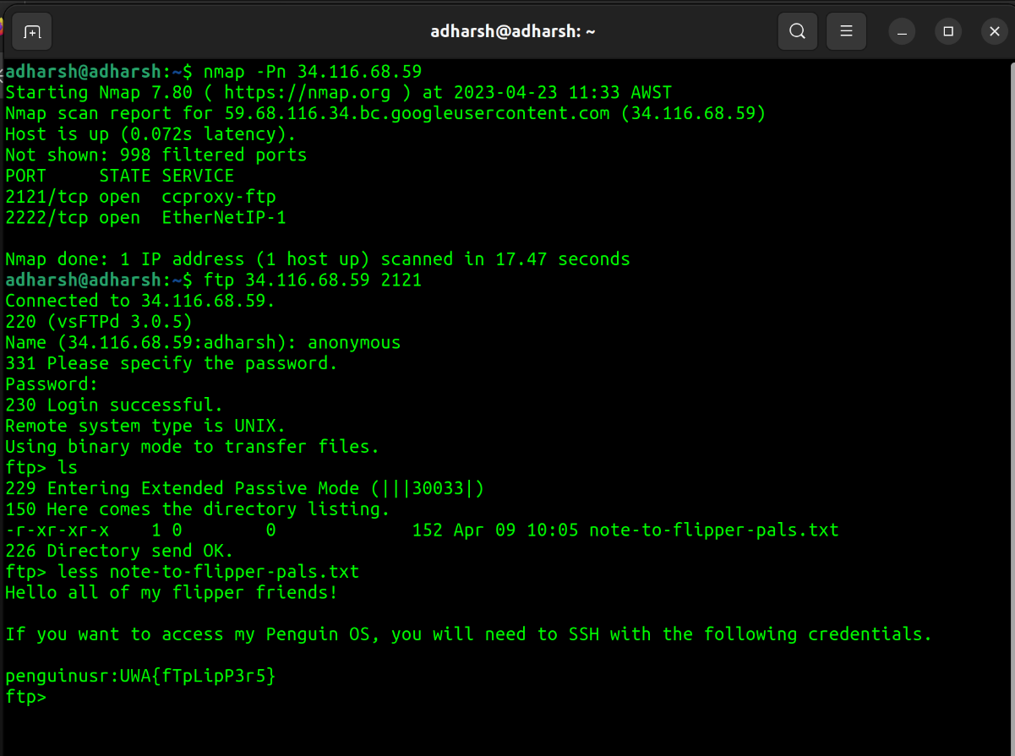

**Explanation:**

Knowing that the target host is online from the question (**“Mumble’ego”**), doing a **nmap** scan with option **Pn** skips host discovery and directly targets the hosts online – **Targeted scanning**. With the result of the scan, we can see an FTP server open, we interact with the FTP server using the command ftp. When prompted for username, trying anything else other than **anonymous** results in an invalid username (“This ftp server is anonymous only”). Guessing that Mumble **did not work on securing** this server properly, just pressing **Enter** when prompted for password results in a successful login – **Exploiting known vulnerabilities/ Password Guessing**.

Penguin OS Part 2: Sea Shells

Use **ssh** to gain access to the server.

The flag is located at **/home/penguinusr/flag2.txt**.

**Steps to solve:**

* Use command **nmap** with options **sV** and **Pn** followed by the IP **34.116.68.59**.
* Use command **ssh** with option **p** followed by port number **2222** and then **penguinusr@34.116.68.59**.
* When prompted for password just press **Enter**.
* Once in, use command **ls** to view the files in the server.
* Use commands **less** or **cat** to view the contents of the file **flag2.txt**.
* The flag is displayed (**UWA{sEcure_S3a_sH3lLs_bI_tH3_sEa_sH04e}**).
* To come out, use command **exit**.

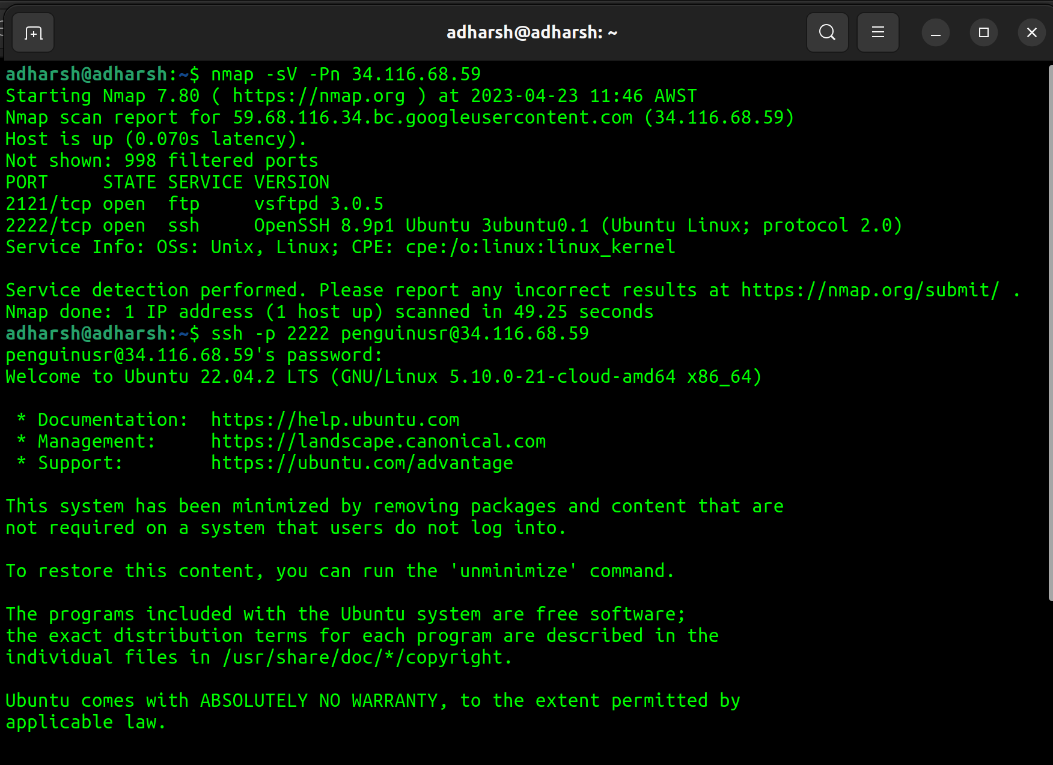

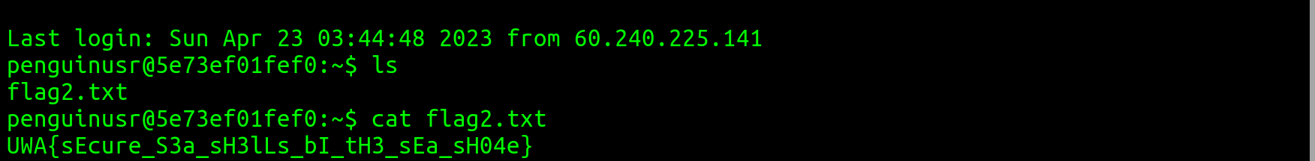

**Explanation:**

Using command **nmap** with option **Pn** skips host discovery and directly targets the host online. With option **sV**, we can get information of the **versions of the services running on open ports** – **Targeted Scanning**. From the question’s hint, we can guess that the port number to use to solve this question is **not** the port number starting as **“21”**. From the scan we did earlier using **nmap** with option **sV**, we get information of open ports also with the service and version details. We see a port number **2222** with **service ssh**. This port number leads to a server with a **secure shell connection (network protocol)**. With all these information, we can come to a conclusion to use **ssh** command with option **p** and port number as **2222** with username **penguinusr** (from the question, **/home/penguinusr/flag2.txt**). Again, knowing that Mumble did not secure the server properly, we just press **Enter** when prompted for a password – **Exploiting known vulnerabilities/ Password Guessing**.

Penguin OS Part 3: Peas in a Pod

Now that you have access to the server, use **linpeas.sh** enumeration tool from **PEASS-ng** to see if you can **find a *password*** for the account named **alex**.

*The server is configured to only allow creating files and folders in the****/tmp****folder on the server.*

**Steps to solve:**

* Once inside the server using the **steps** from the **previous question**, knowing from the question that file/folder creation is allowed only in the /tmp folder, use command **cd** followed by **/tmp**.
* Use command **wget** followed by the link <https://github.com/carlospolop/PEASS-ng/releases/latest/download/lineas.sh>.
* Use command **chmod** with option **755** followed by **linpeas.sh.**
* **Run** the script file by typing **./lineas.sh**
* Use command **su** followed by **alex**.
* When prompted for password enter **gonnawhackmykeyboardtomakesecure92p8yij37u49723ihuj23esdf.**
* Switch to home directory using command **cd** followed by **home**.
* Switch to alex’s directory using command **cd** followed by **alex**.
* Use command **ls** to view the files in the directory.
* Use **less** or **cat** to view the contents of the file **flag3.txt.**
* The flag is displayed (**UWA{d0Nt_pVt_s3Ns1TiV3_d4t4_iN_l000000g5}**)
* To come out, use command **exit.**

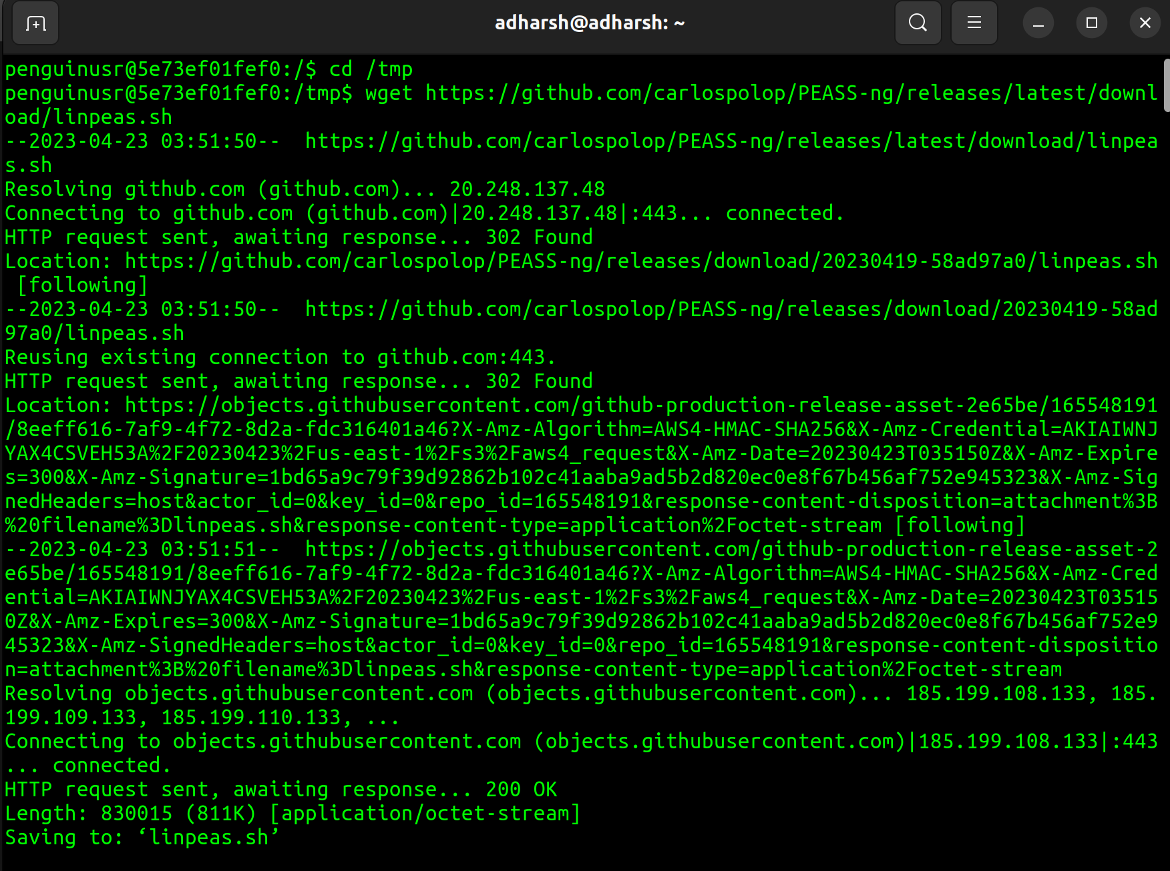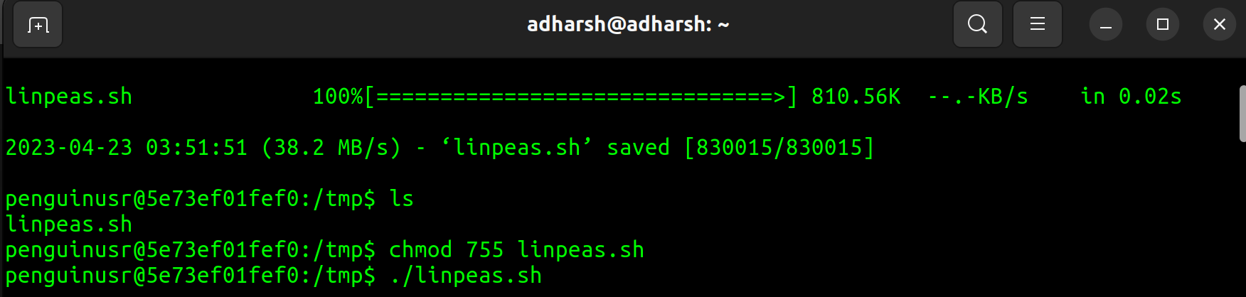

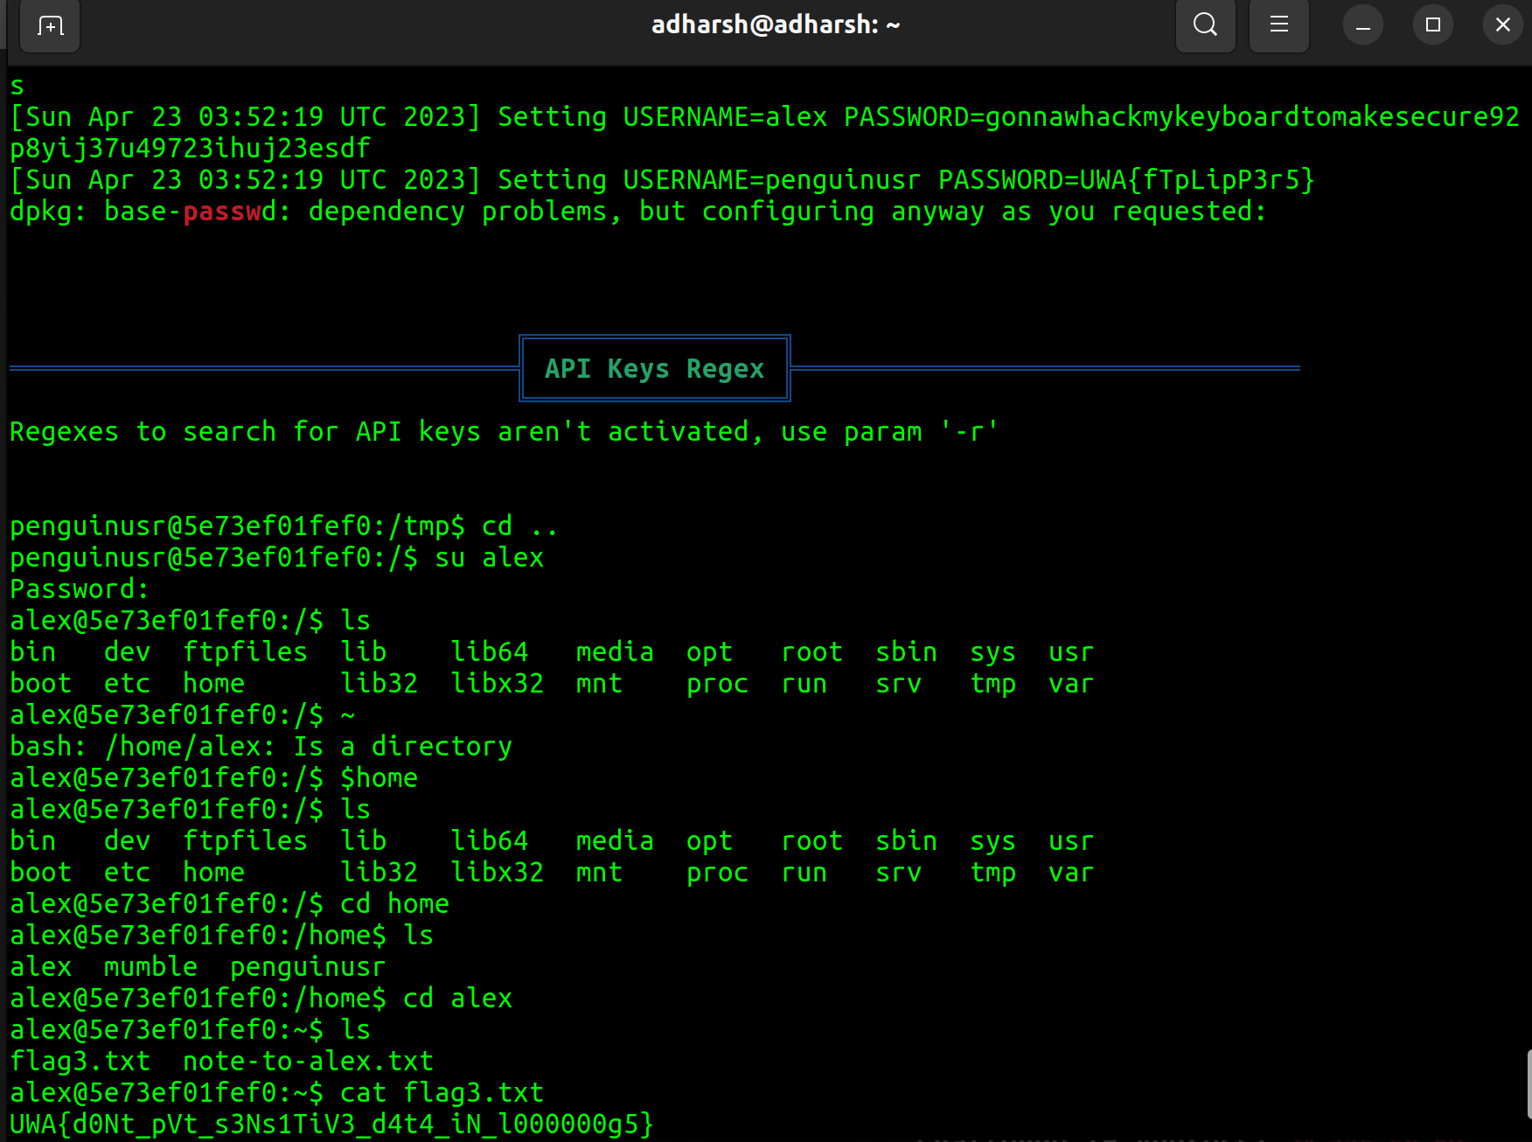

**Explanation:**

The script file exploits the vulnerabilities in the server by accessing the **data** in the **log files** and file/folder creation that is allowed in the /tmp folder - **Exploiting known vulnerabilities** and **Data Breach.** Command **su** is used to switch to the user “alex”.

Penguin OS Part 4: Scheduled Hack

**mumble** left a passive aggressive **note** to **alex** that can be read at **/home/alex/note-to-alex.txt.**

*Based on the note, can you figure out a way to read the* ***final flag*** *at****/home/mumble/flag4.txt.***

**Steps to solve:**

* While in the server, use command cd followed by **/opt/admin-scripts.**
* Create a script file using command **vim** followed by script file name (I have decided to use **ans_for_4.sh**).
* In the script file, write the code displayed in the **image below**.
* To **save** the script file with the code, first press **Esc** key, then “**:**” and finally type “**wq**” and press **Enter**.
* Use command **chmod** with option **755** followed by script file name(**ans_for_4.sh**).
* Switch to **/tmp** dir. using command **cd** followed by **/tmp**.
* Wait for **less than a minute** or **keeping trying,** to **view the files** in the directory using command **ls**.
* Eventually a **text file** with **the same file name as our script file** shows up, view the contents of the file using commands **cat** or **less**.
* The flag is displayed (**UWA{d0Nt_g0oF_y0_sCh3dUl3d_t4sK5}**).
* To come out, use command **exit.**

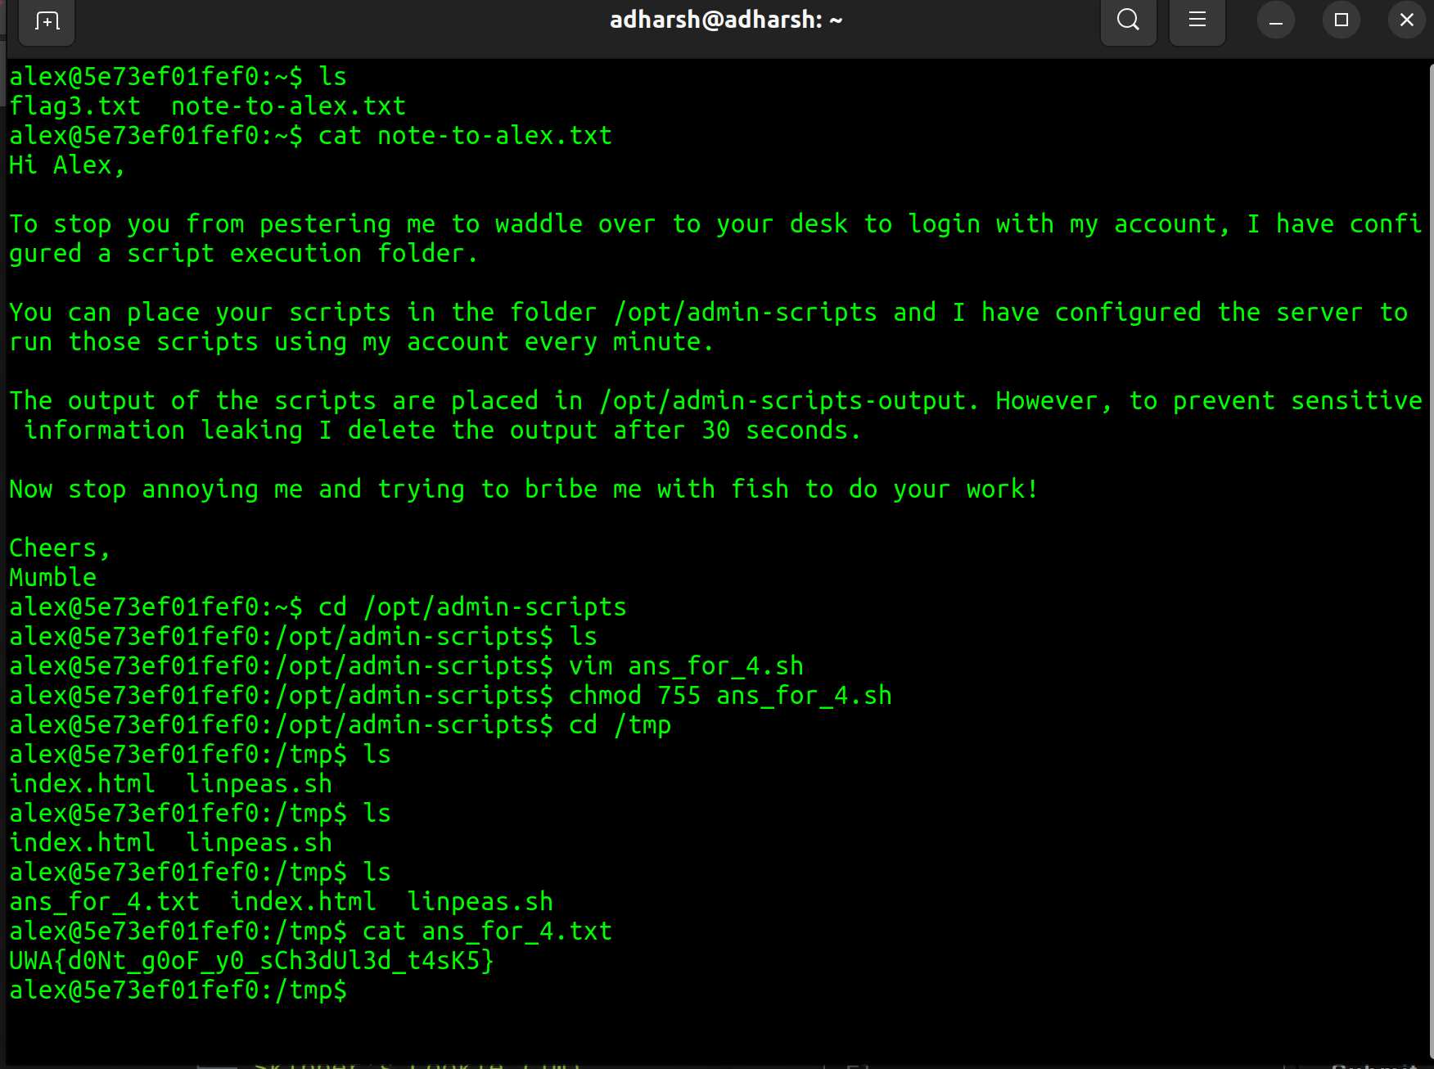

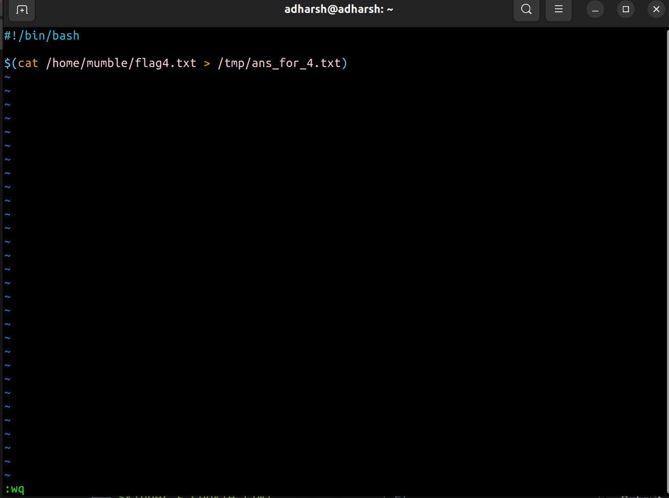

**Explanation:**

By reading the file **note-to-alex.txt**, we can come to know that **alex** has been given permissions to **write script files** and execute them with **super user permissions.** Even though this can only be done in a particular folder, we misuse this power by writing a **simple output redirection code**. Since this file is **executed** by the **super user itself**, **any command** in this file will also be run using **super user permissions**, thus allowing us to do anything we want to. – **Misuse of power/permissions.**

**Project2: Cryptography**

Penguin Translator School

*Can you figure out what the emperor penguin wrote on the whiteboard using****CyberChef****?*

**Steps to solve:**

* **Copy** the **given text** into any **word processor**, here I have used **NotePad**.
* Replace “**wa**” with “**.**” using **Find and Replace** operation of NotePad found in the **Edit** tab, which can be found in the **Menu** bar.
* Replace “**woo**” with “**_**” or “**-**” using the **same operation** from **previous step**.
* Copy and paste the modified text into the **Input** section of the CyberChef platform.
* From the **Operations** tab, search for **From Morse Code.**
* Drag and drop it into the **Recipe** section. Set letter delimiter as **Space** and word delimiter as **Line feed.** (These are the default values set in this operation)
* We get the flag in the **Output** section (**UWA{WAA_WAA_W00_MEANS_I_H4V3_L0ST_MI_5AN1TI!ONE}**).

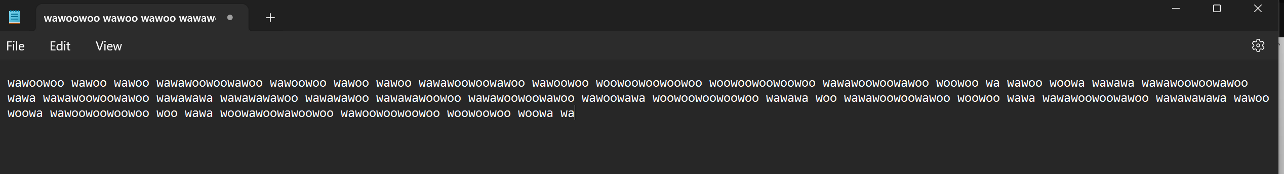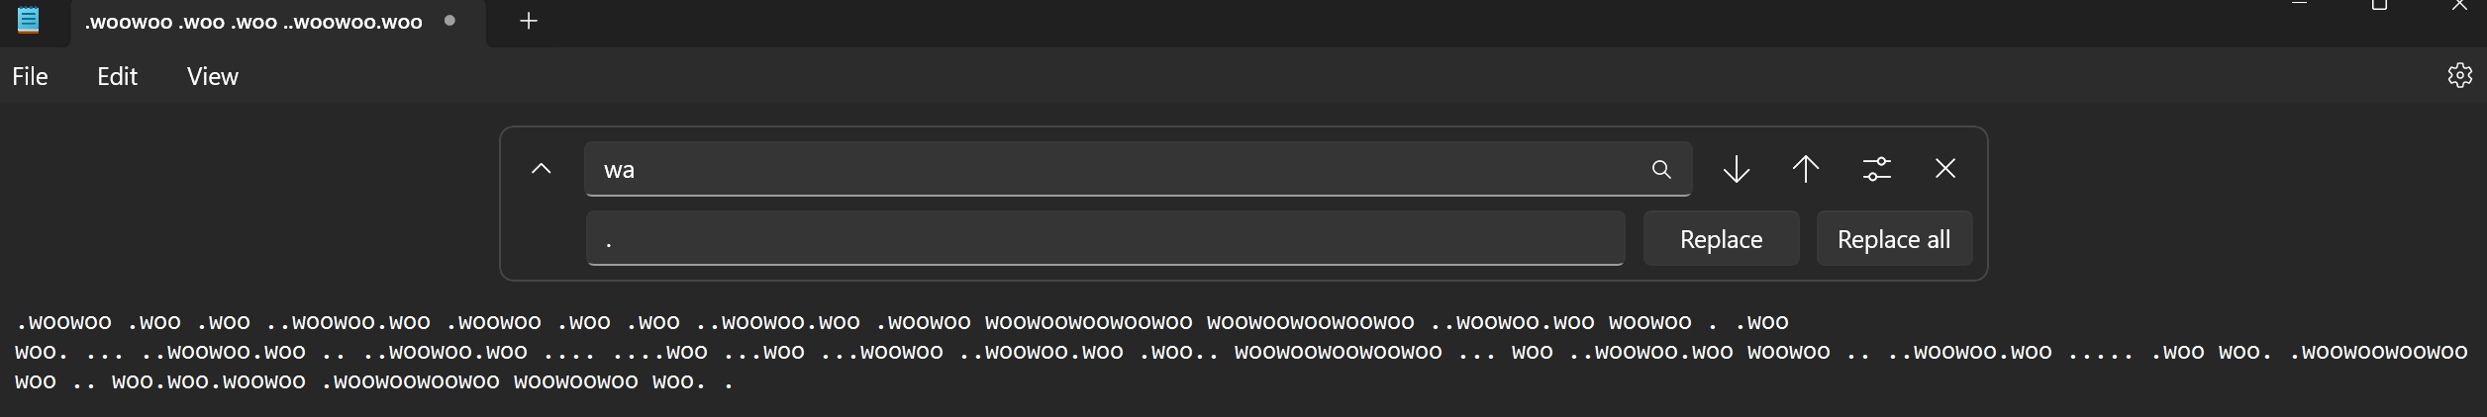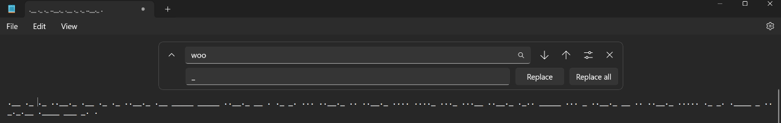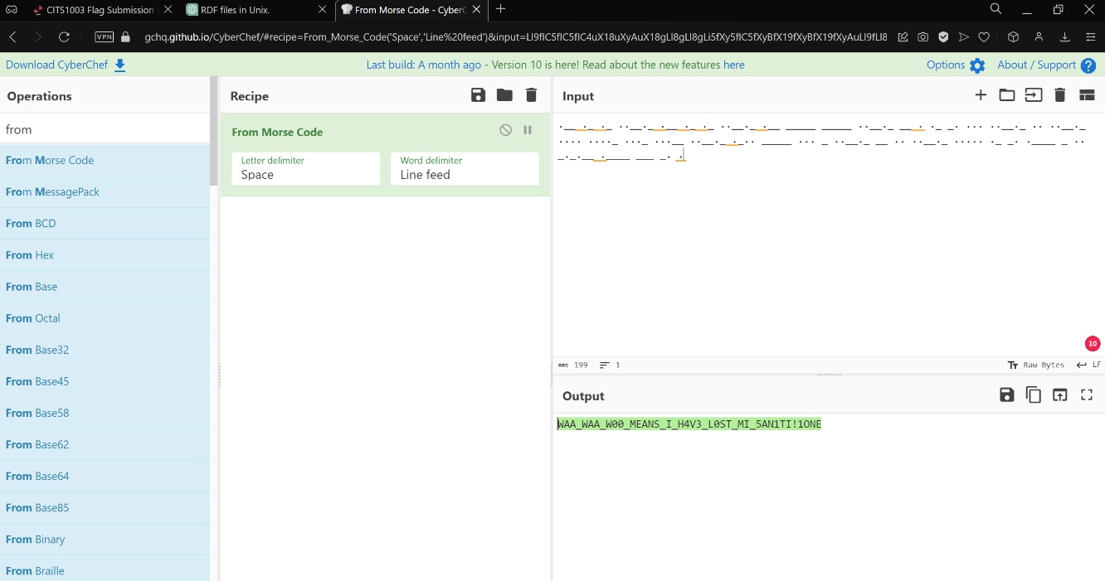

**Explanation:**

We can guess from the **given text** that it **resembles** the **Morse code** with “**wa**” representing the “**.**” and “**woo**” representing “**_**” or “**-**”.

Pingu’s Fish Sauce Recipe

You have hacked into **Pingu's** computer to steal their **top secret** fish sauce recipe. You see a PGP encrypted email in Pingu's inbox and wonder if it contains the delectable recipe that you want to attain. After snooping around on **Pingu's laptop,** you find their **PGP public** and **private key files**.

*Can you* ***decrypt*** *and* ***decode*** *the fish sauce recipe?*

**Steps to solve:**

* In **CyberChef**, search for **PGP Decrypt,** drag and drop it into the **Recipe** section,copy and paste the text from **recipe-message.txt** into the **Input** section. Copy and paste the text from **ping-pgp.priv** into the **Private key of recipient** field.
* Search **ROT13**, drag and drop it into the **Recipe** section. Check **Rotate lower-case chars** and **Rotate upper-case chars.** Set the **Amount** value to **19**.
* From the **Output** section copy the text ‘**nootnootnootnoot**’from the second line.
* Search **AES Decrypt**, drag and drop it into the **Recipe section,** paste the copied line into the **Key** field and in the **IV** field as well and select **IV format** as **UTF8** and **mode** as **CBC.**
* Set **Input** value to **Hex** and **Output** value to **Raw.**
* Search **From Base64,** drag and drop it into the **Recipe** section.
* Search **From Hex,** drag and drop it into the **Recipe** section, the flag can be found in the **Output** section. (**UWA{pL34s3_sToP_tH3_cYb3r_cH3f_ch4lL3nG3s!1!}**)

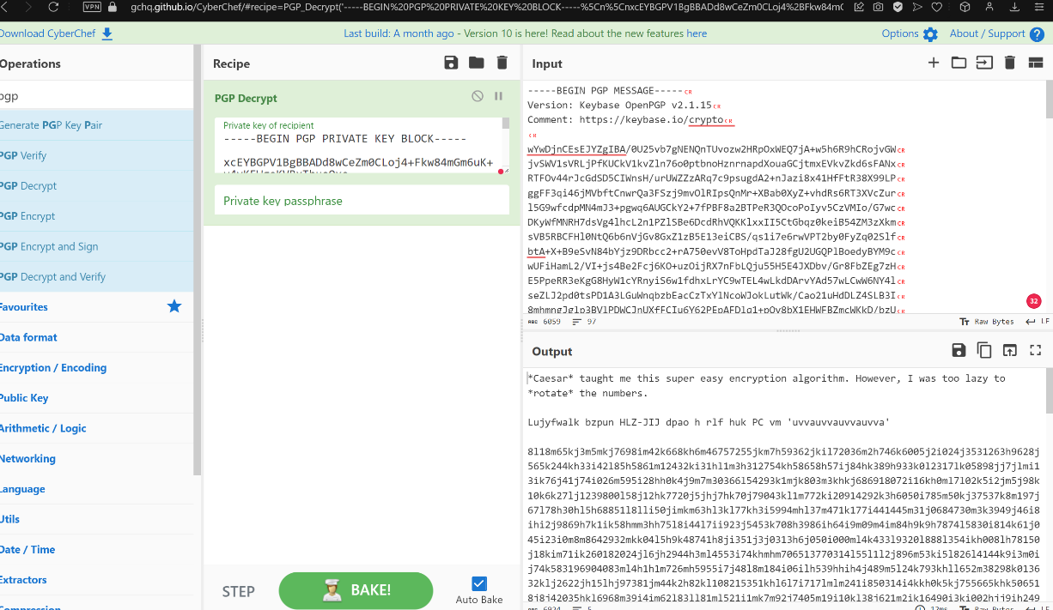

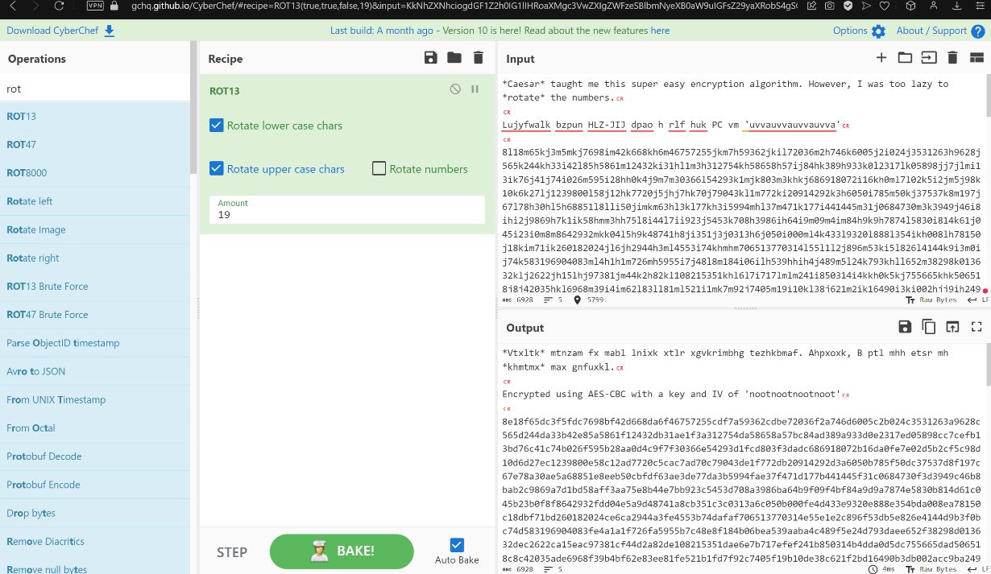

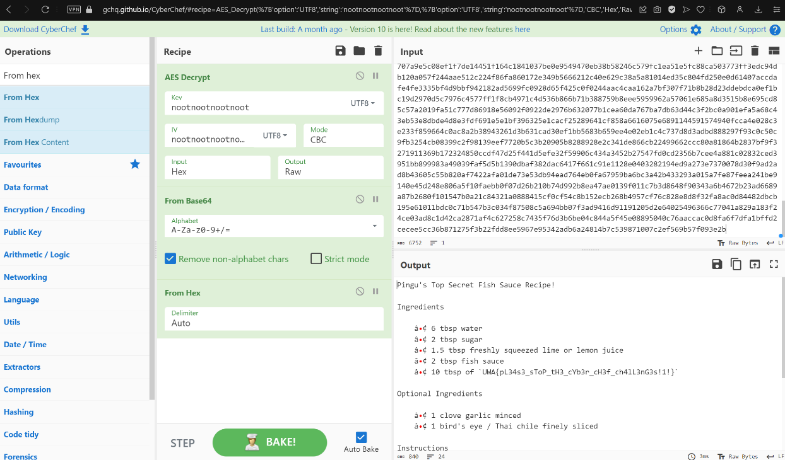

**Explanation:**

From the question, we can guess that we have to use **PGP Decrypt**. Doing so with the text of **recipe-message.txt** and **pingu-pgp.priv** gives us two words as clue, **Caeser** and  **Rotate.** So, we use **ROT13**, cycling through the amount, at **19,** we get another clue that **AES-CBC** was used to **encrypt** and we get the **key** and **IV** used to do it as well**.** So, we use **AES Decrypt**. The output from the previous operation results in a text that resembles **Base64.** So, we use **From Base64,** which results in an output that is in **Hex.** Finally using **From Hex,** we get the flag.

Penguin RSA

**Can you decrypt the penguin's message that was encrypted using their RSA algorithm?**

**Steps to solve:**

* Install python3 if not available using command **apt install python3-pip**.
* Install pycrytodome using command **pip install pycrytodome.**
* Modify/Include the code into **solvetemplate.py** using the **given image below**.
* Run the modified file using the command **python3 solvetemplate.py.**
* The flag is returned to the terminal. (**UWA{mAyB3_i_sH0vLd_sT0p_3aTn_f15h_Nd_k33p_mI_pR1m35_s3CvRe!!one!}**)

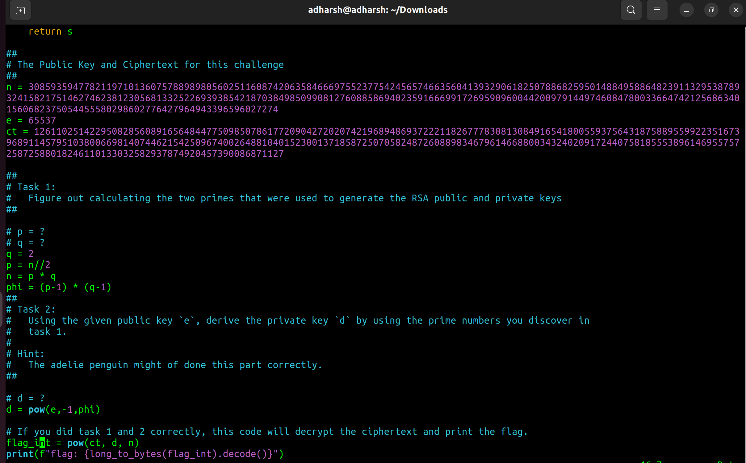

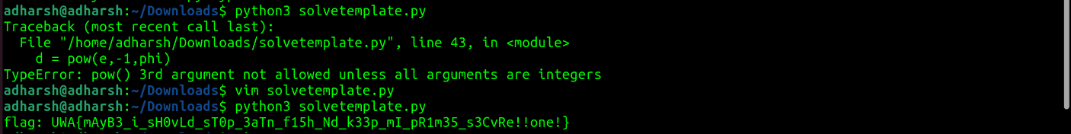

**Explanation:**

From the question we know that **RSA** encryption is being used. The encrypting method is mentioned in the question and several pre-written module crypto modules are required to solve this question. This is acquired by installing **pycryptodome**. Using basic math and manipulating the formulas, we get values of **p, q, phi, and d.** The python script prints the flag, we get the correct value of the flag if the variable values are correct.

Flippin Auth

***Can you figure out a way to trick Pingu's website that you are the admin user?***

**Steps to solve:**

* Go into the Penguin’s Server, by clicking on the server ([**http://34.87.251.234:3001/**](http://34.87.251.234:3001/)) given in the question.
* Enter **guest** as username and **password1234** as password.
* Get the cookie value by **right clicking** on the page and click on **Inspect,** navigate to **Application** tab and click on **Cookies** drop down from the **Storage** section. (This was done using Chrome/OperaGX brower.)
* Copy the value from **Value** field.
* Go to **CyberChef,** search **From Hex,** drag and drop it into the **Recipe** section. Paste the copied text into the **Input** section.
* Search **XOR,** drag and drop it into the **Recipe** section. Use **admin** as the **key (UTF8)**.
* Again, drag and drop **XOR** into the **Recipe** section. Use **guest** as the **key (UTF8).**
* Search **To Hex,**  drag and drop it into the **Recipe** section. Use space as delimiter.
* Copy the first ten characters from the output (excluding the space characters).
* Replace the first ten characters in the **Value** field’s value with the copied text.
* Refresh the page to get the flag. (**UWA{cH1aM0_1_p1nGvIni!1}**)

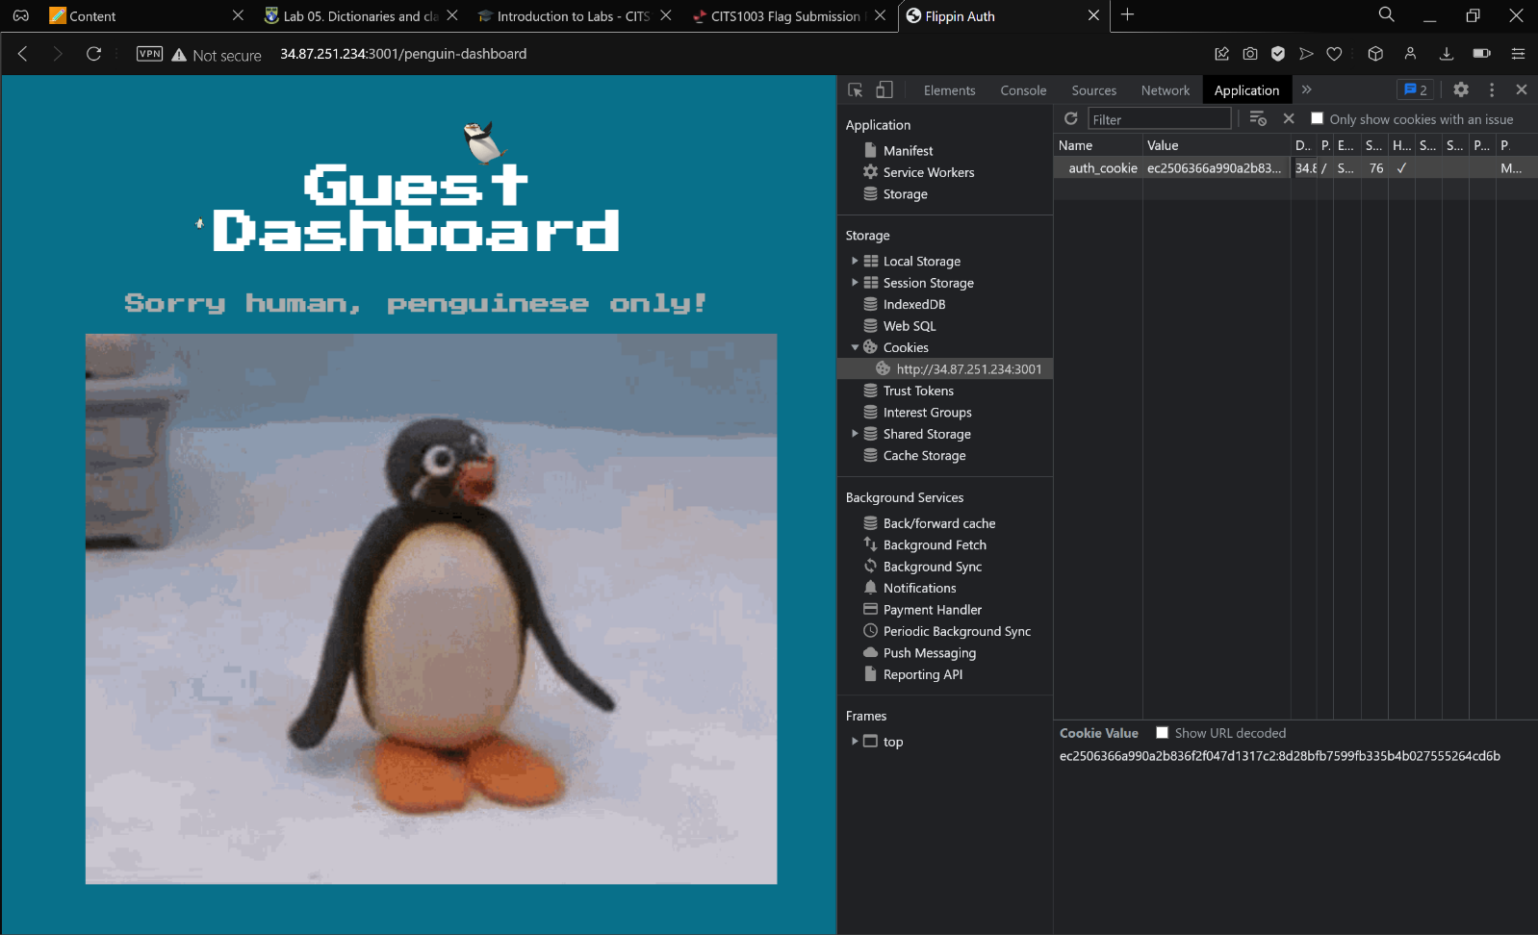

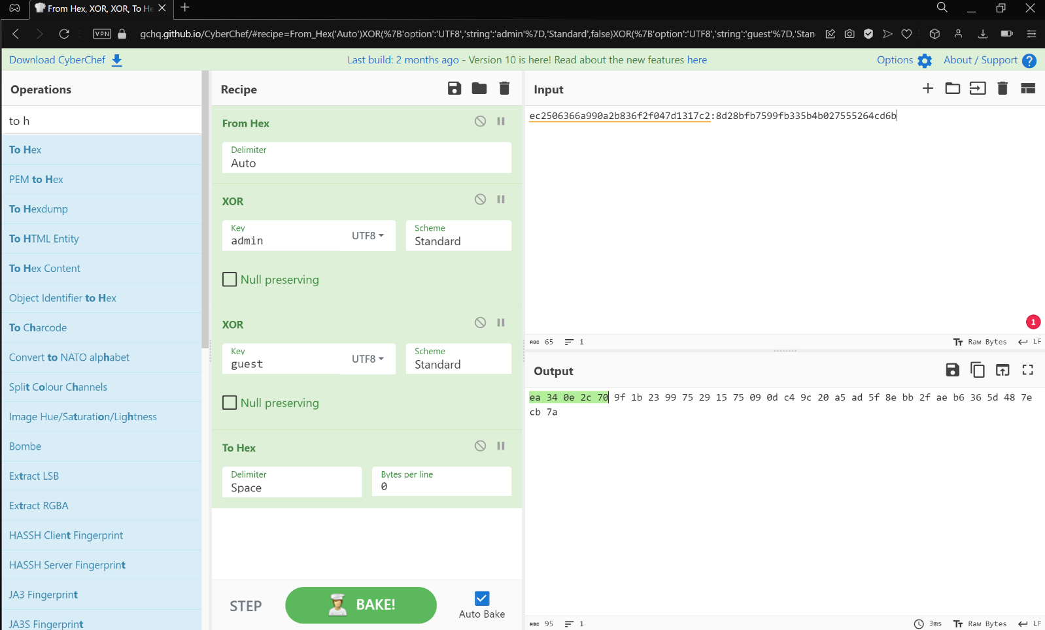

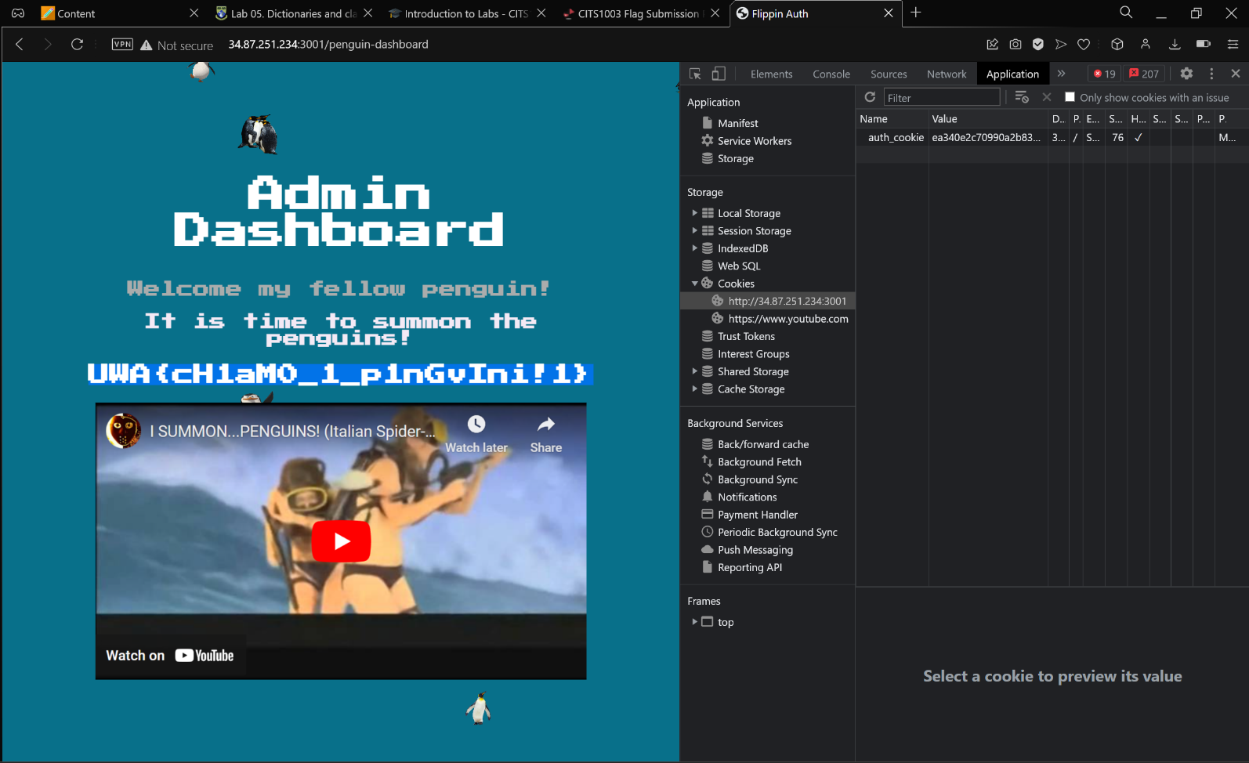

**Explanation:**

We can find the steps to follow in **CyberChef,** by just concentrating on one single equation in the AES-CBC encryption explanation file given with the question. By manipulating the formula, we understand that, we need to alter the **auth_cookie** by changing its **first 10** values. We know that the **auth_cookie** we get when we login as **guest** is result of **AES Decryption** in the format {IV:encryted_username}. The values of decryption are in **hex;** hence we use **From Hex.** Using **XOR** and key as **admin,** we change the decrypted value to resemble **username** as **admin**. This output is then **XOR’d** with key as **guest** to resemble that the decrypted value is still that of the **guest.** Then the output is changed **To Hex** to resemble the decryption result of the **AES-CBC.** Knowing from the hint that only the first 10 values of the **auth_cookie** is to be changed, we change it with the first 10 values from the output and reload the page to get to the **admin page**.

**Project3: Forensics**

Noot Noot

*Using the attached image, can you figure out the nearest station where* ***Pingu*** *took the photo?*

**Steps to solve:**

* Install exiftool by using the command **apt-get install exiftool.**
* Use command **exiftool** followed by the filename **not-noot.jpg.**
* Search in google map using values **77 50’ 30.59 s 166 41’ 10.75 E.**
* The flag is the station name **(UWA{McMurdoStation}).**

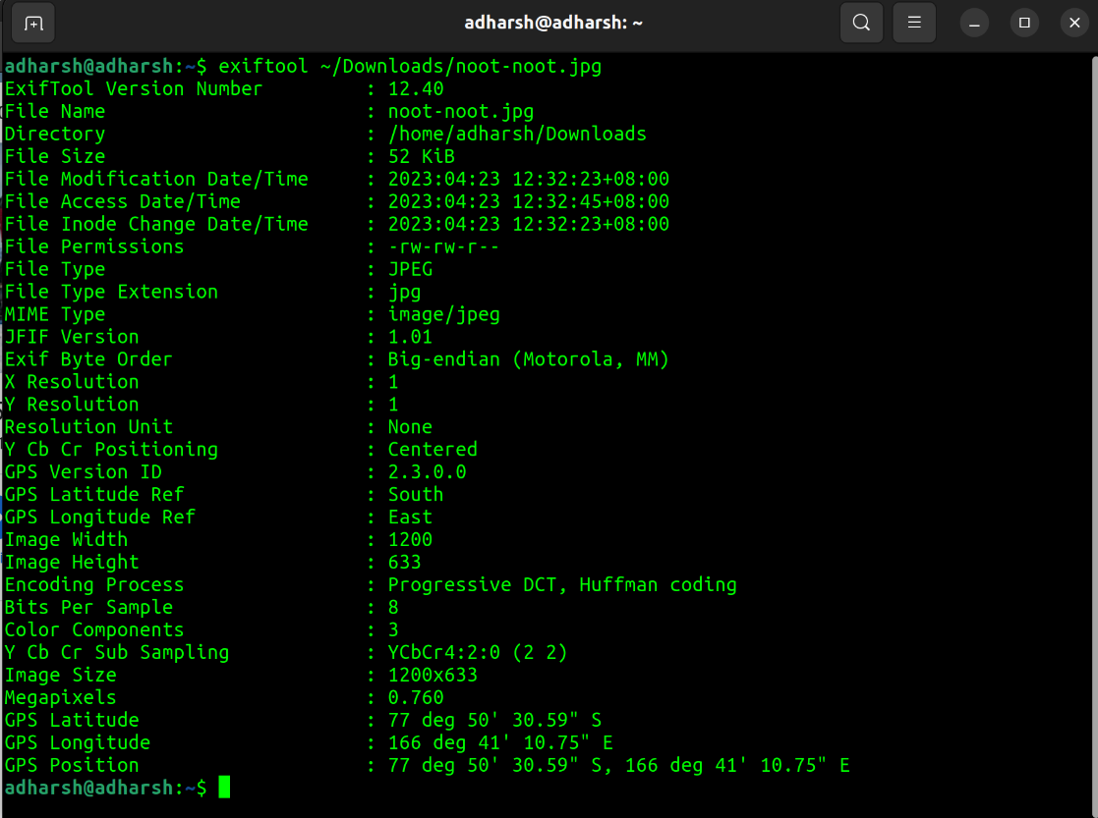

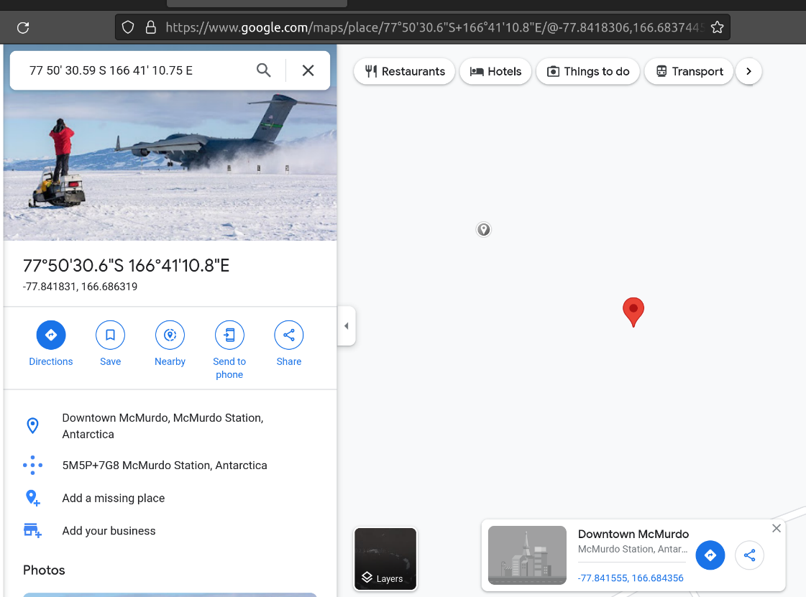

**Explanation:**

Using google, we could learn that there is a tool called **exiftool** to read the metadata of a file. **Metadata** is nothing but the data about the file such as filename, size etc.

Penguin Trap Music

*Can you use****steghide****to extract the message from the* ***song****?*

**Steps to solve:**

* Install steghide using the command **apt install steghide.**
* Use command **steghide** with option **extract** followed by extraction option **sf** and finally the filename **song.wav.**
* When prompted for password, just press **Enter.**
* Use command **ls** to view the files in the directory.
* Use command **cat** or **less** to view the contents of the file **msg.txt.**
* The flag is displayed. (**UWA{b455_i5_g00d_2_34t1!one!}**)

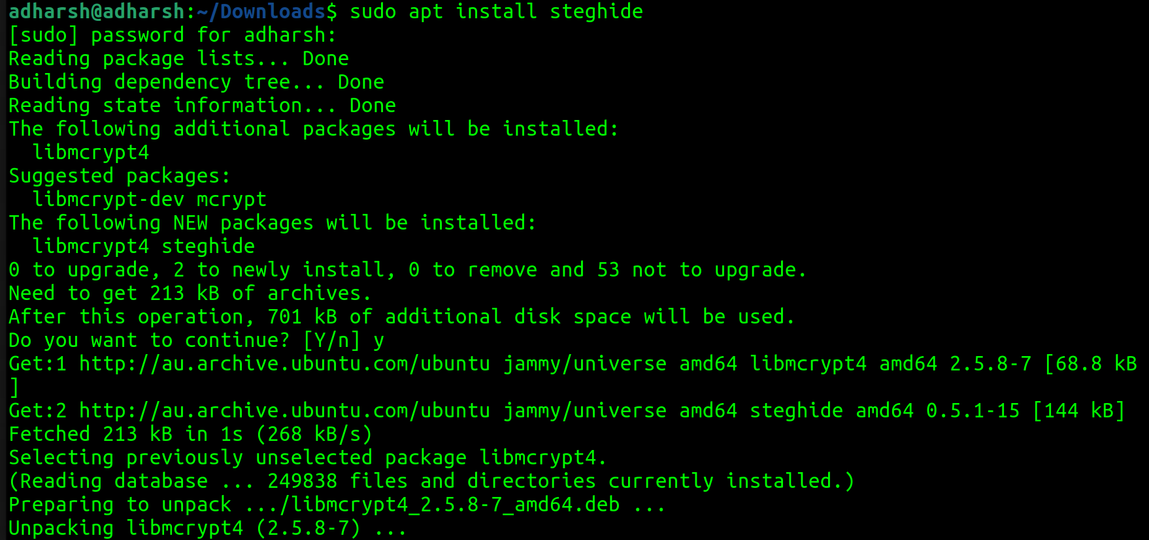

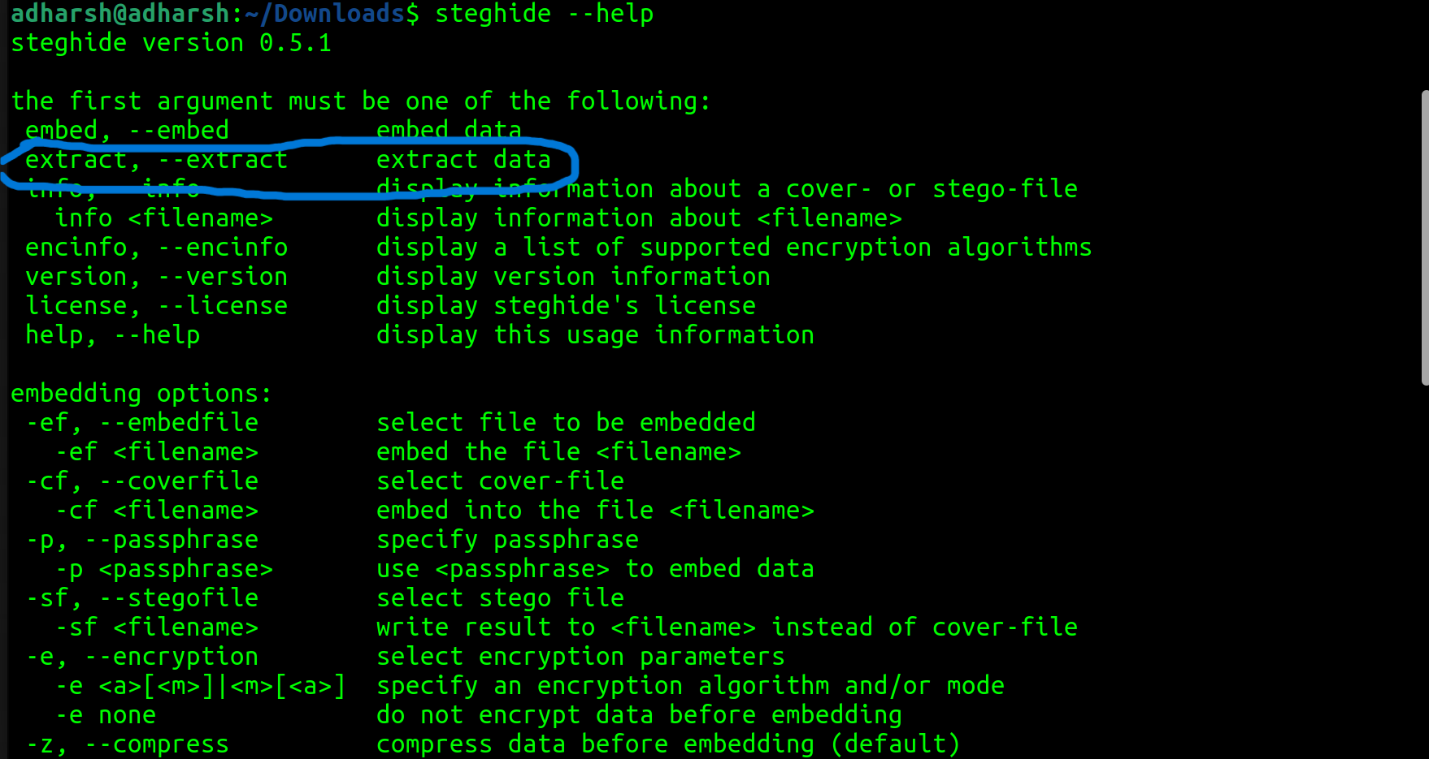

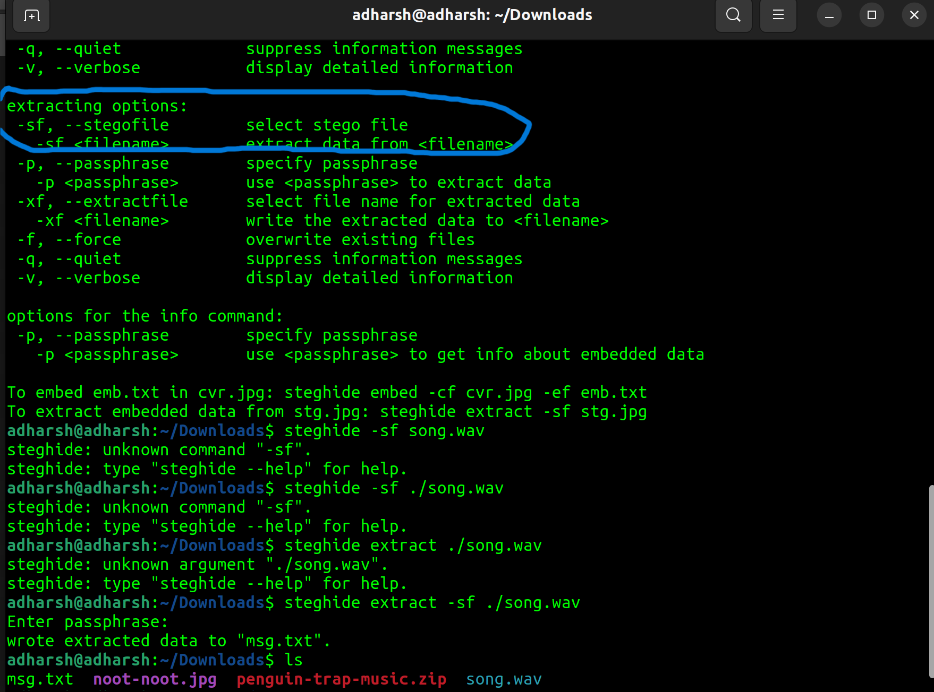

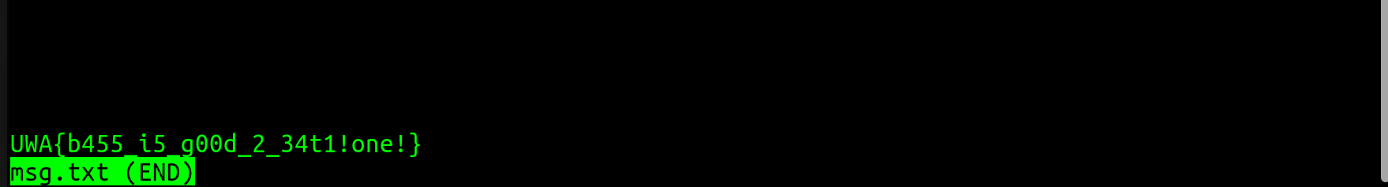

**Explanation:**

From the question it is clear that the concept of **Steganography** is used to conceal **Pingu’s** secret message into a song. The concept of **Steganography** is to conceal information within other data types. This concealed/embedded data is not visible to the naked eye. To get the embedded data we use the command **steghide** and extract the information using **extract** option with **sf** as extraction options since the file that we using(**song.wav**) is a **stego file.**

Fishy Doc

*Can you investigate the* ***document*** *Pingu sent and figure out how* ***Mumble was hacked****?*

**Steps to solve:**

* Rename the downloaded file **fishy.odt** to **fishy.zip** using the command **mv fishy.odt fishy.zip.**
* Unzip/extract the **fishy.zip** file using the command **unzip** followed by the zip filename.
* Use command **ls** to view the files in the directory.
* Use command **cd** to change directory to “**./Basic/Standard/**”**.**
* Use command **less** or **cat** to view the contents of the file **Module1.xml.**
* The flag is displayed (**UWA{f15hy_m4cR0s_nD_ch3353}**).

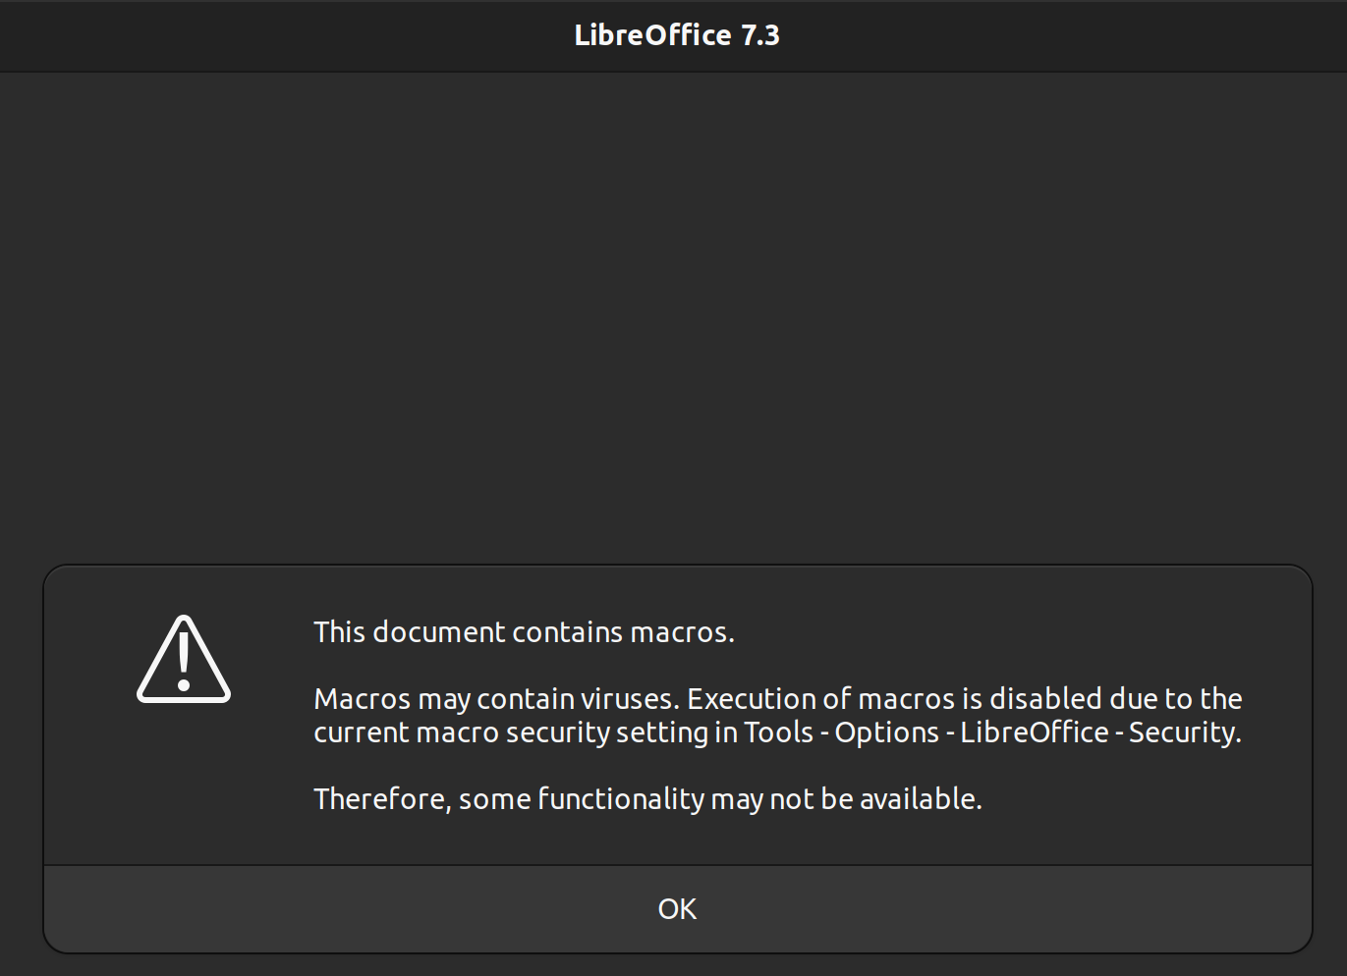

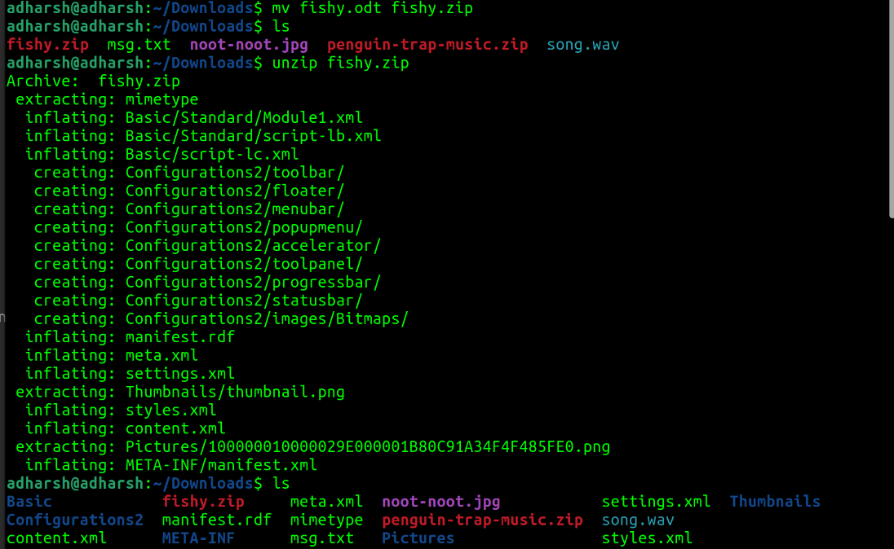

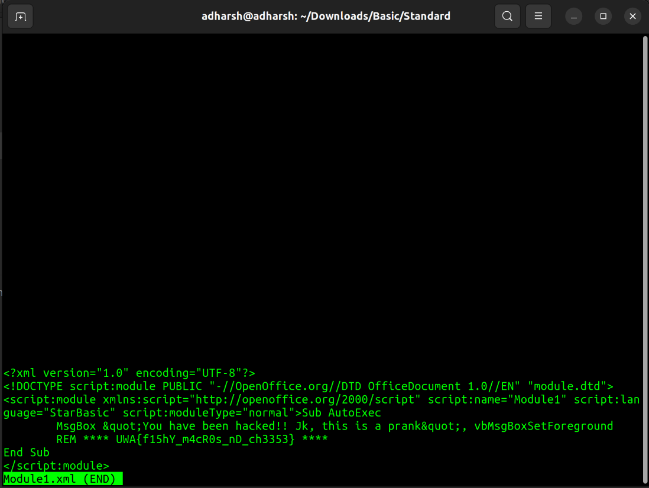

**Explanation:**

To get started and understand what’s happening, I tried opening the file **fishy.odt, LibreOffice** displayed **warning message** that the file contains **macros.** Googling **what are macros** and **how to extract them** from a file with **odt** extension, showed me that I had to first rename the file to **.zip**. Then I came to know that macros are written as codes and they are generally contained in the folder **Scripts/Basic.** Using cat command to view the contents of file **Module1.xml,** I found the flag.Macros are sequences of instructions or commands that are recorded and saved to be used as automated repetitive tasks in future use.

Mumble’s Revenge

*Can you* ***reverse engineer Mumble's malware*** *and* ***read the contents of the message box*** *that is shown?*

**Steps to solve:**

* Install **liblnk-utils** using the command **apt install liblnk-utils.**
* Use command **lnkinfo** followed by the file **ClickMePingu.lnk**
* Copy the text from **Command line arguments.**
* Open **CyberChef,** paste the copied text into the **Input** section.
* Search **From Base64,** drag and drop it in the **Recipe** section.
* From the **Output** section, copy the **link** and download the file **MunblesRevenge.exe.**
* Use commands **cat** or **less** to view the contents of the file **MumblesRevenge.exe.**
* Copy the text after **pingu** till the end of **“=”**.
* In **CyberChef,** paste the copied text into the **Input** section.
* Search **From Base64,** drag and drop it in the **Recipe** section.
* The flag is displayed in the **Output** section (**UWA{h4Ck3D_bY_tH3_l1Nk3d_cH41N!!1one}**).

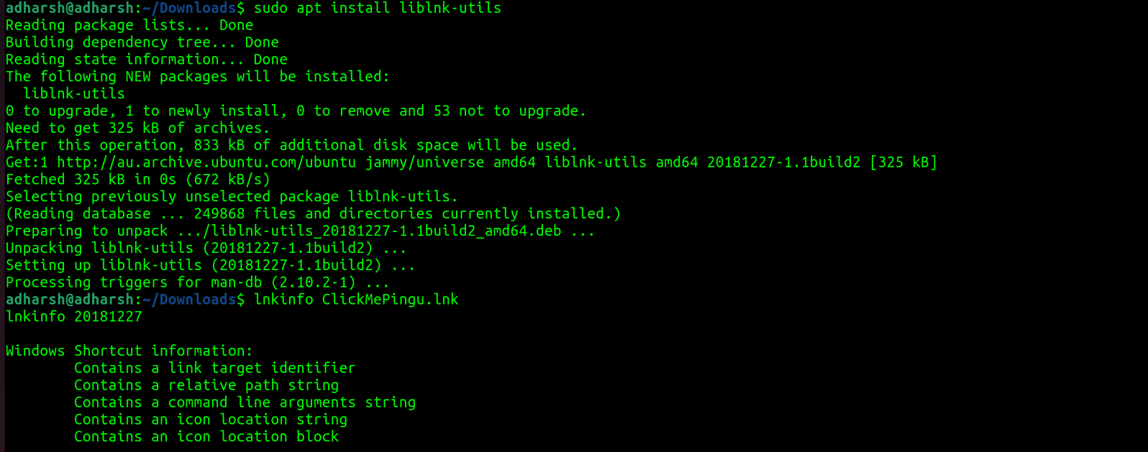

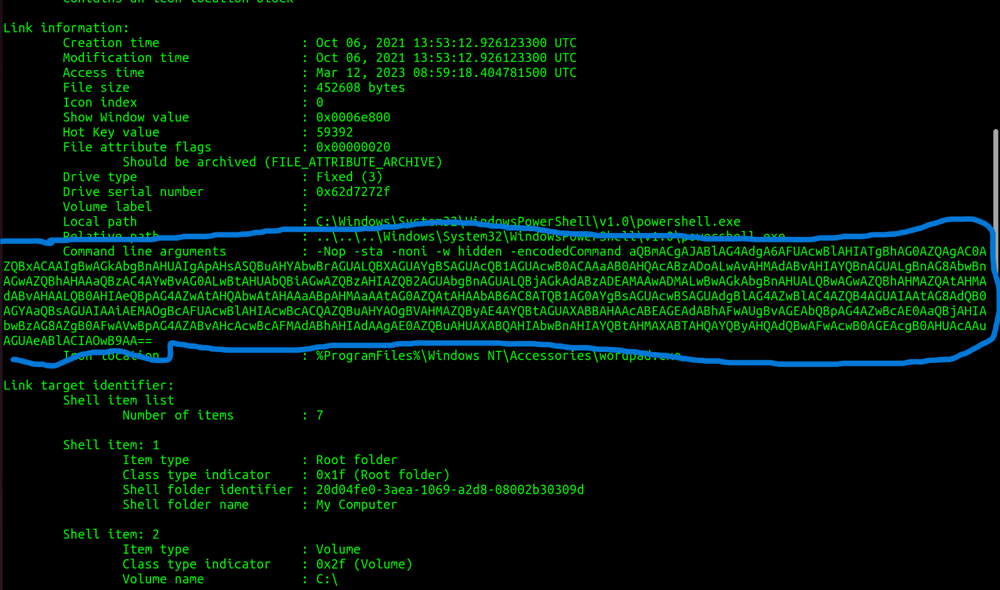

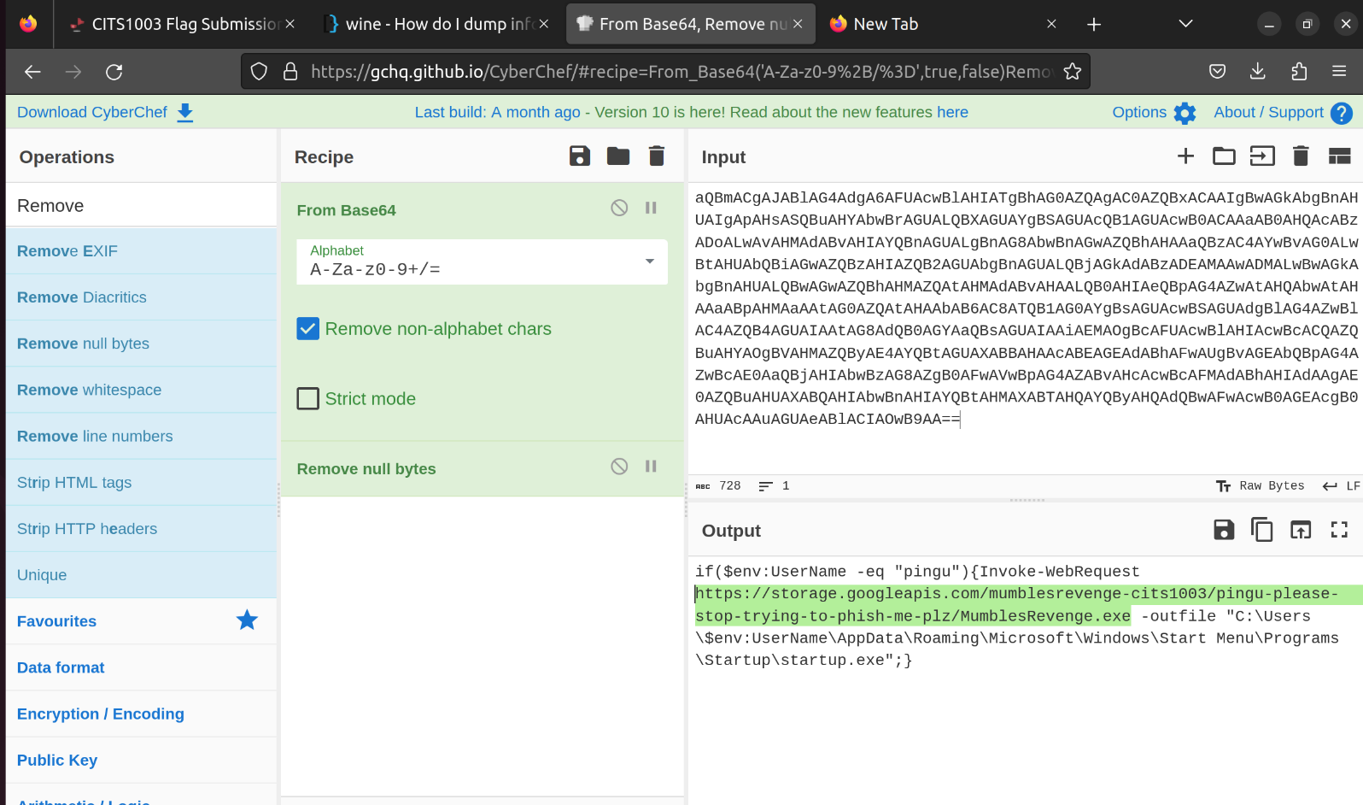

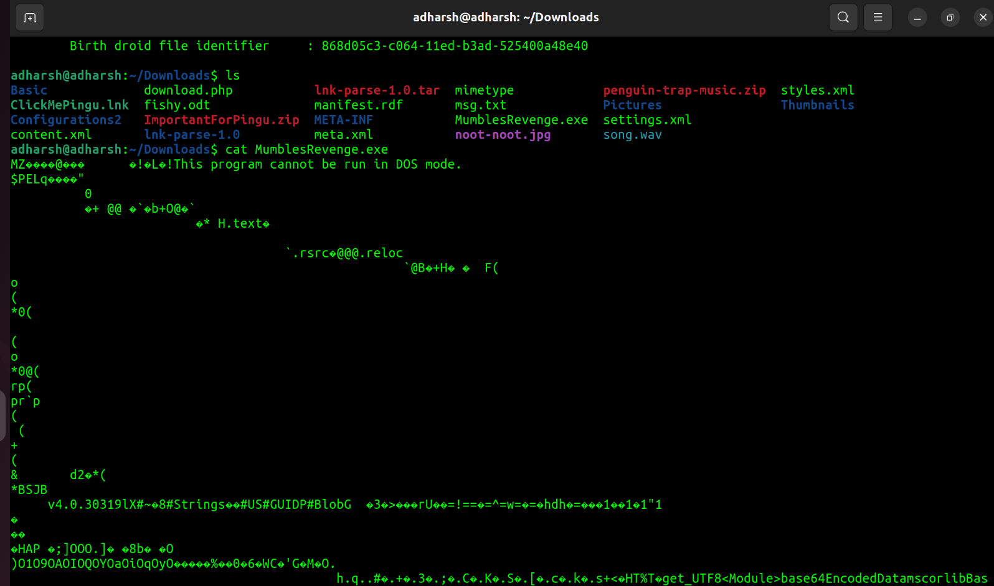

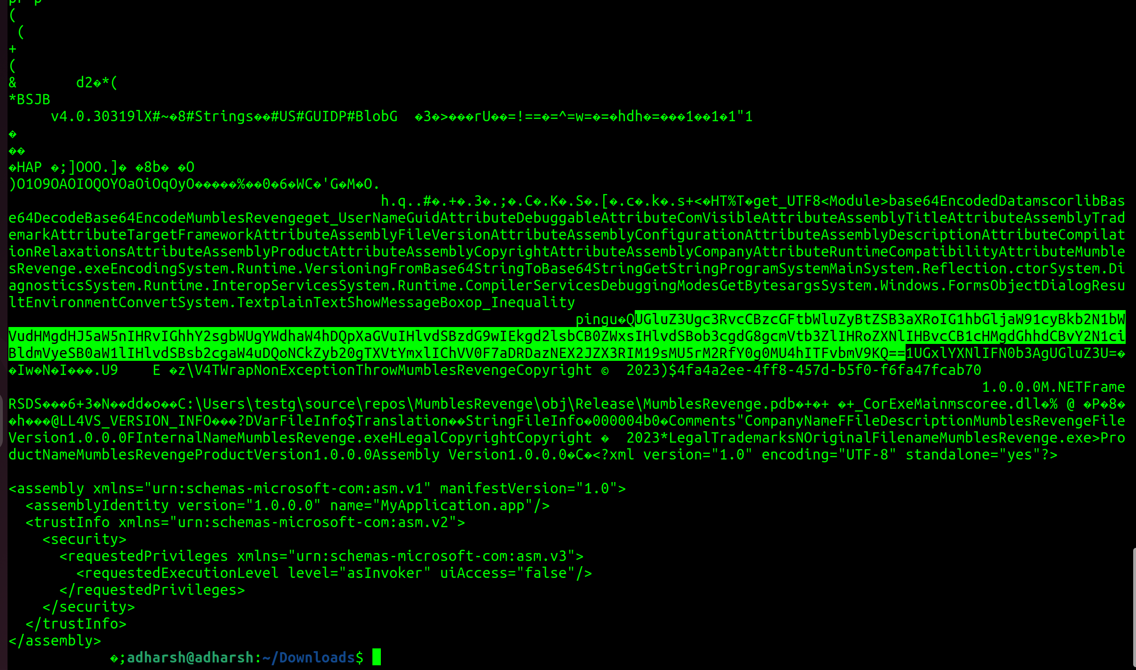

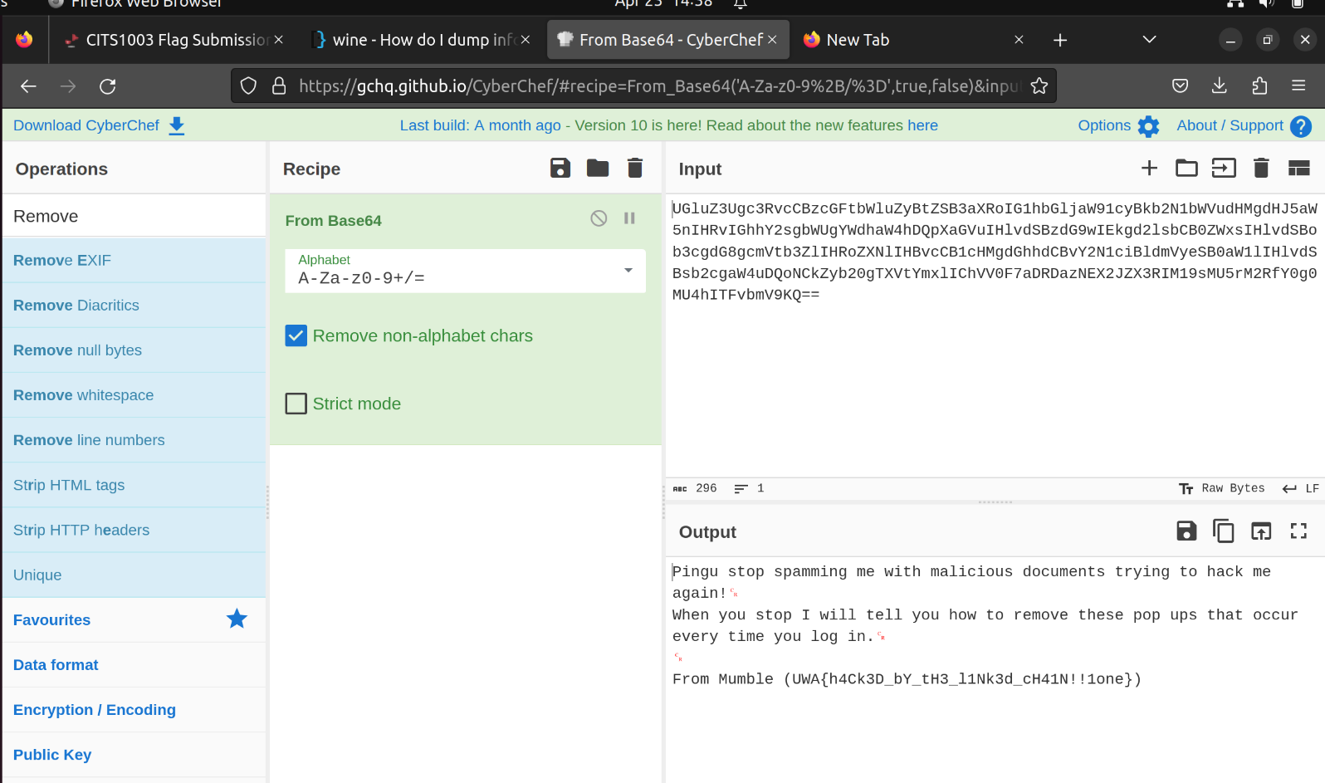

**Explanation:**

To read a **lnk** file, we need to use **lnkinfo** command. Using it we can get the info of the **ClickMePingu.lnk** file. In the **Command Line arguments** field, I found text in the **Base64** format, using cyberchef to decode it, gave me a link, which downloaded a file. Since I was using Ubuntu, I couldn’t do much with **MumbleRevenge.exe,** I used **cat** command to read the file, which revealed that it is a encoded script file in the **Base64** format. So I used cyberchef to decode which gave me the answer.

**Project4: Vulnerabilities**

Arctic File Storage Part 1: Surfing for Vulns

**Steps to solve:**

* Go to the Server specified in the question.
* In the **Address bar,** modify the URL to [**http://34.87.251.234:3000/robots.txt**](http://34.87.251.234:3000/robots.txt)
* Again, modify it to [**http://34.87.251.234:3000/admin/login**](http://34.87.251.234:3000/admin/login)
* In the redirected page, right click and inspect the source code.
* Search about Directus in Google.
* The flag is **UWA{CVE-2023-26492}.**

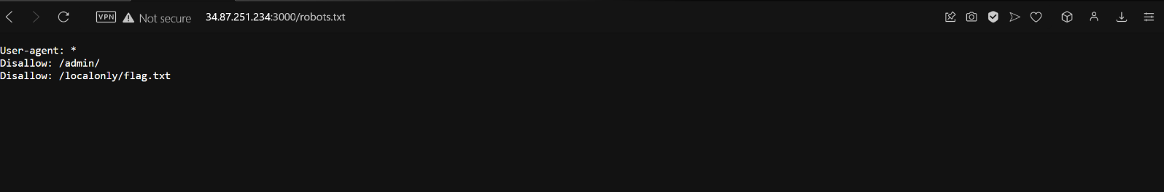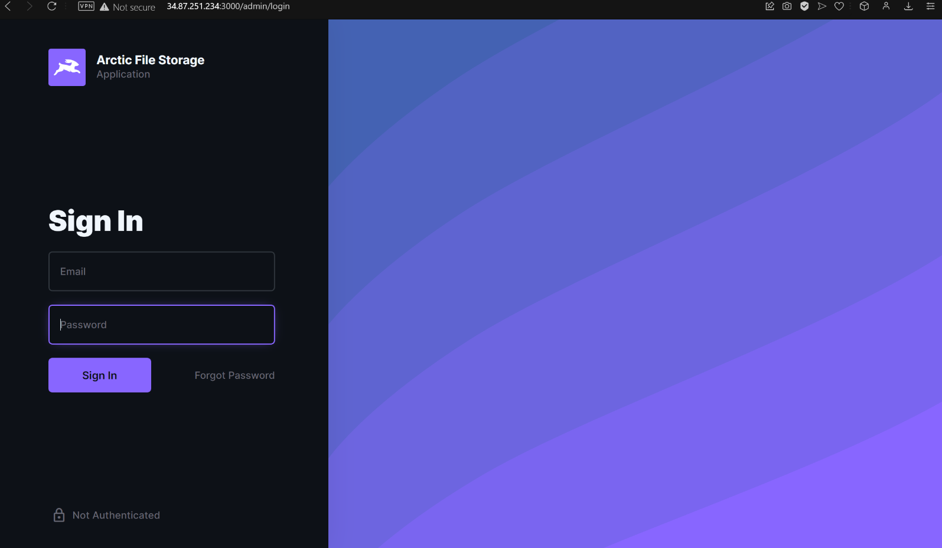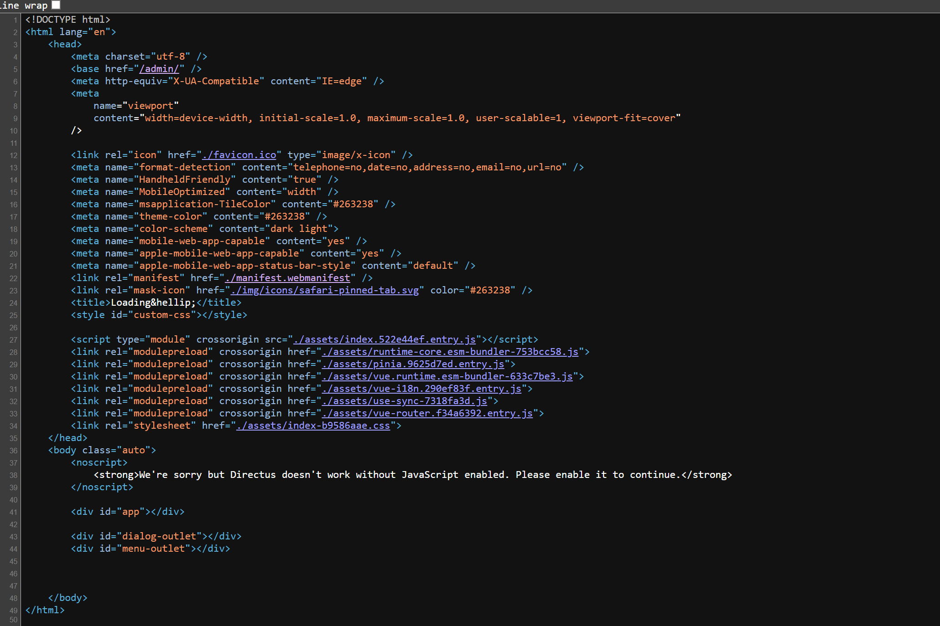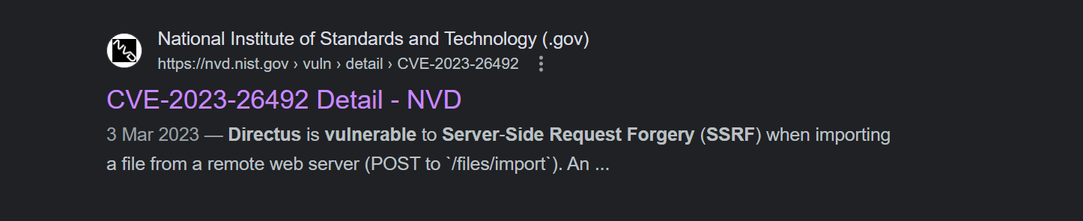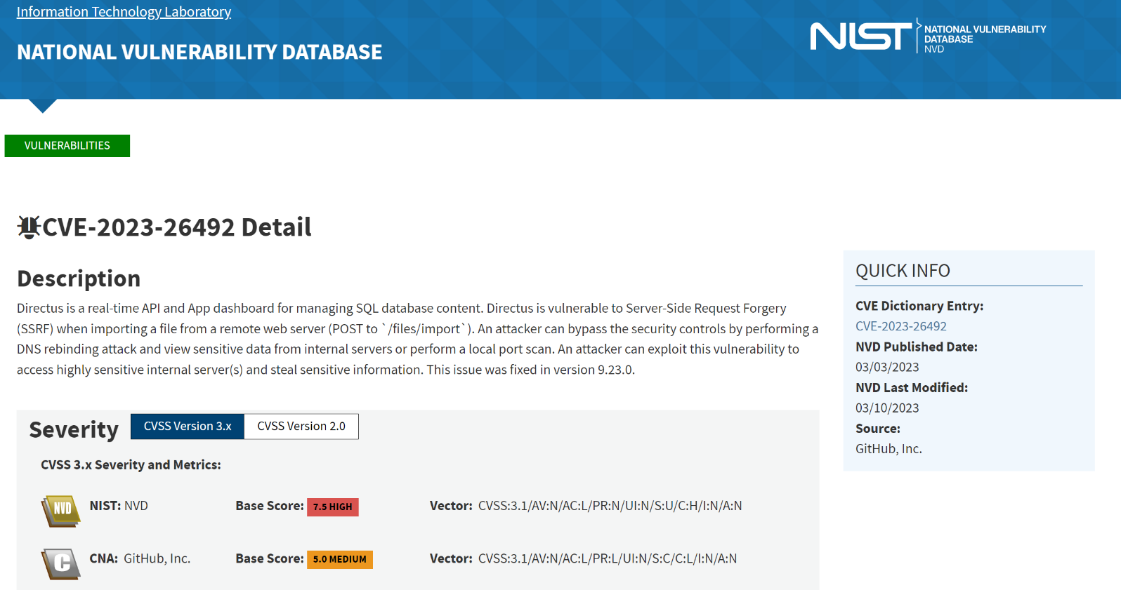

**Explanation:**

Redirecting to said robots.txt, reveals that /admin redirect is not allowed but playing with it and changing it from /admin/ to admin/login caused a **DNS rebinding attack**. This led to a login page, inspecting the login page, in the source code, **Directus** was mentioned. This terminology was not familiar to me, so I searched in Google which revealed that it was a real-time API that has a vulnerability and the answer would be the vulnerability’s CVE ID.

Skipper’s Cookie

Can you figure out a way to trick the website that you are **Skipper** to steal his **cookie**?

**Steps to solve:**

* Go to the server mentioned in the question.
* Right click and click on **Inspect page element.**
* Navigate to **Application** tab and click on **Cookies** section. (This was done in Chrome/OperaGX browser).
* Change the values of **user** from **Guest** to **Skipper.**
* The flag is displayed. (**UWA{c0000k13s_N0m_n0m_n0M!!one11!}**)

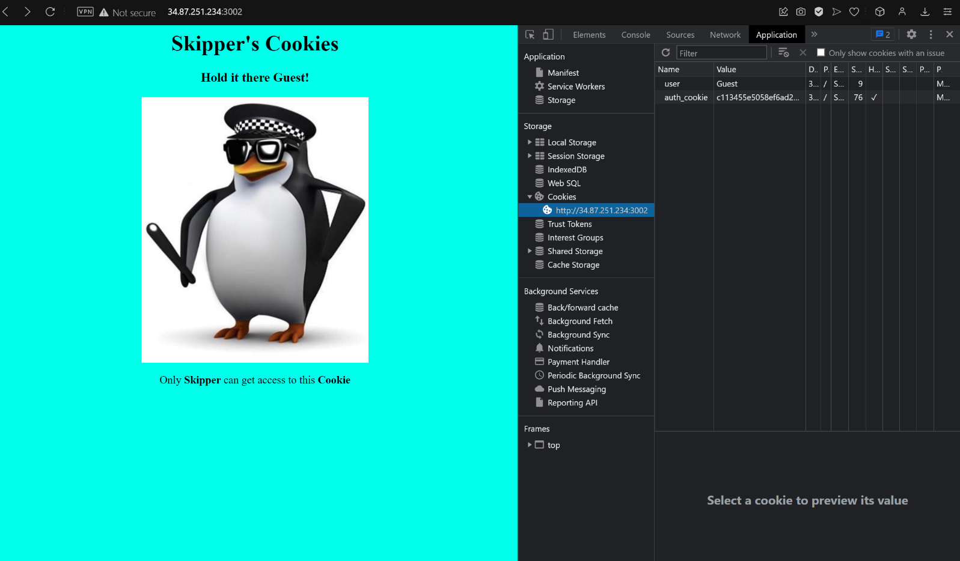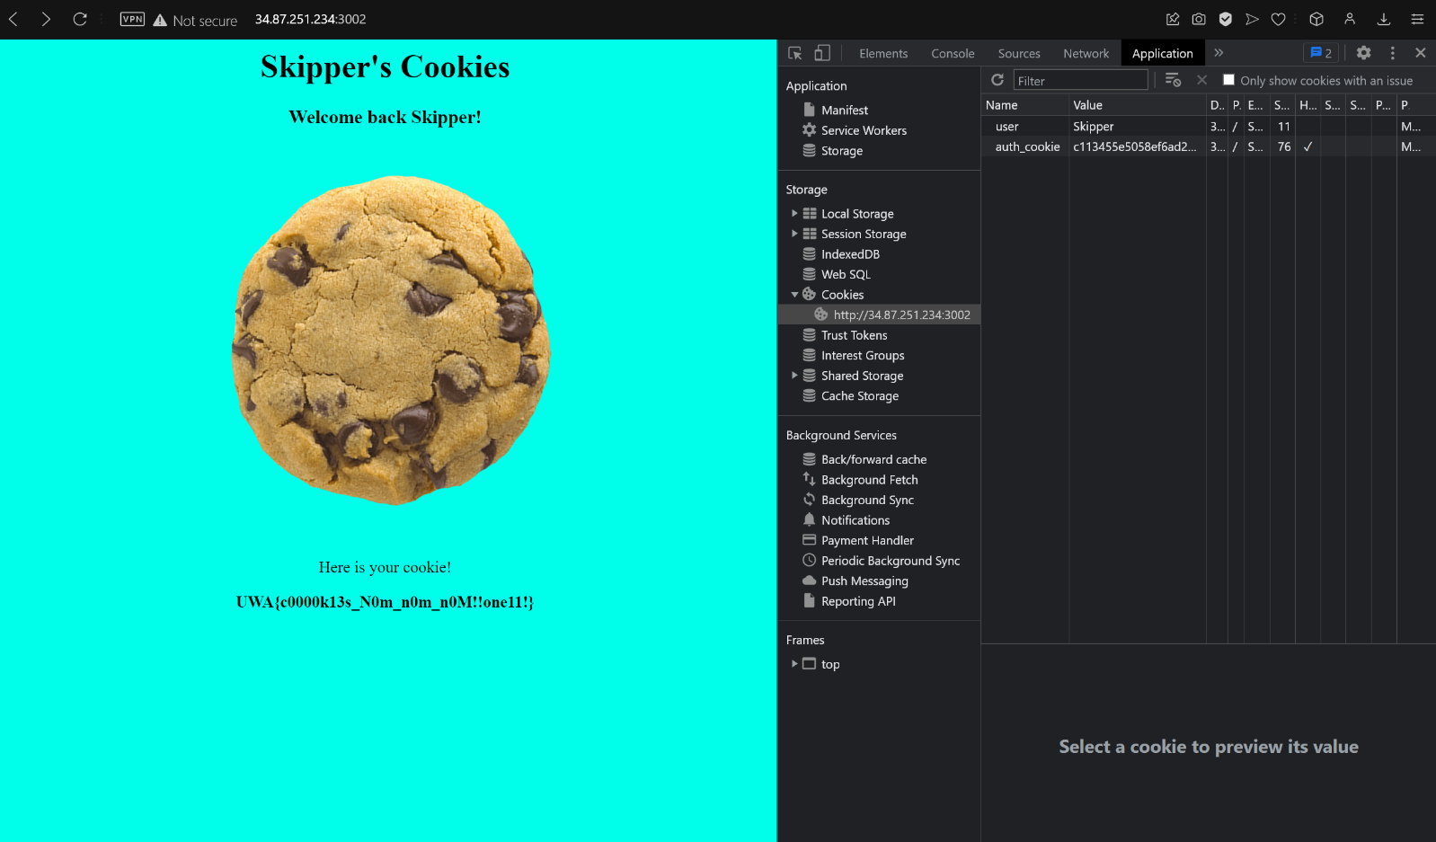

**Explanation:**

From the hints, I managed to understand that manipulating the value of **user field** under **cookies** to **Skipper** would redirect me to **Skipper’s page.**

Arctic File Storage Part 2: Rewind Rebind

Using the vulnerability, you found in Part 1, can you figure out a way to view the contents of /localonly/flag.txt?

**Steps to solve:**

* Go to the website <https://lock.cmpxchg8b.com/rebinder.html>.
* Enter IP 34.87.251.234 in A’s field and IP 127.0.01 in B’s field.
* Copy the result displayed.
* Go to the server specified in the question.
* Paste the rebinded IP in the URL to save field and modify it to:  **2257fbea.7f000001.rbndr.us:3000/localonly/flag.txt**
* Click on the Submit button until you get the pop up **File is ready** and click on **Download. (**I had to submit for at least 500 times to get the pop-up**)**
* The downloaded file contains the flag.

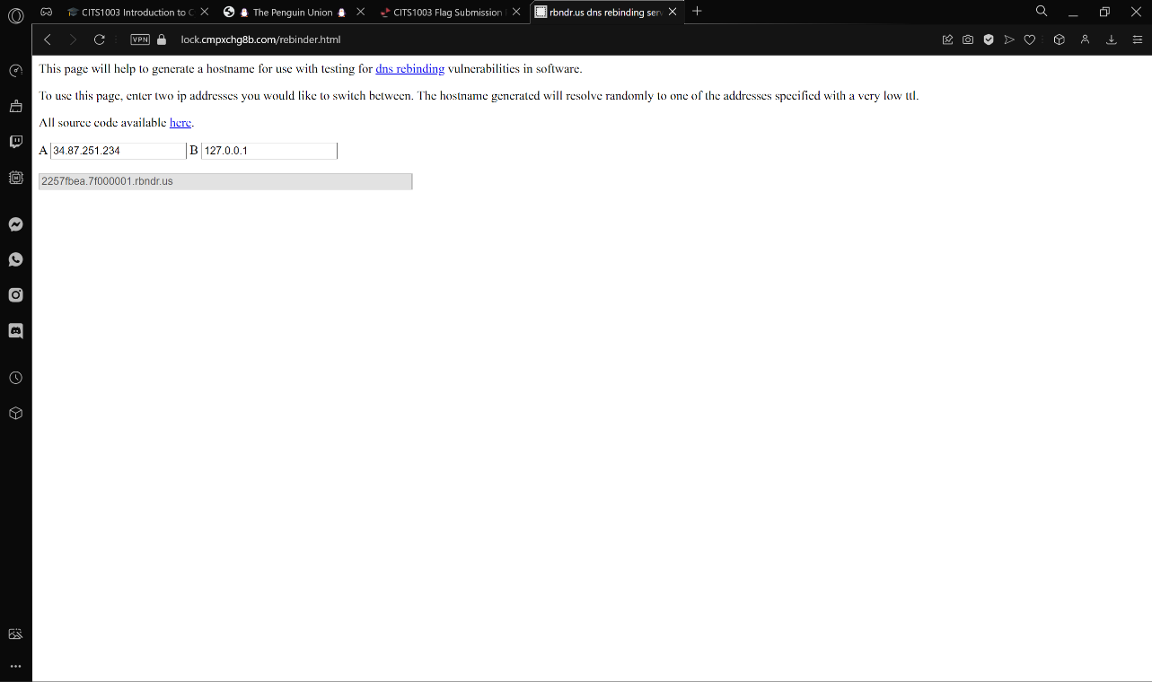

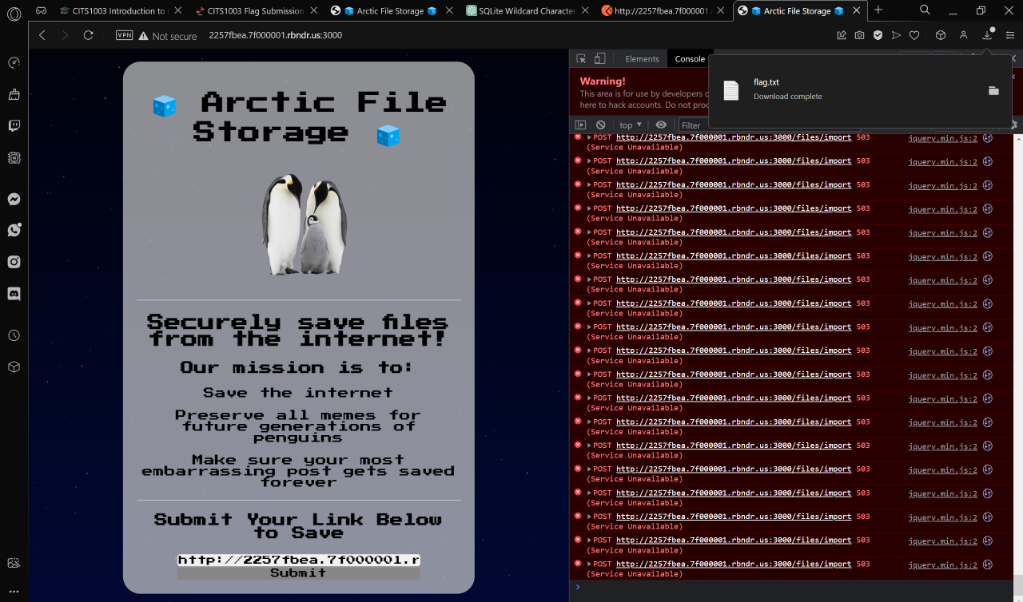

**Explanation:**

To solve this question, I used traditional DNS Rebinding attack by dumping the modified URL in the **Submit** field.

Penguin Union

*Can you figure out a way to leak the****address****of the penguins that have registered to join the union?*

**Steps to solve:**

* In the **search field,** type the following query:

**select * from registrations -- %' union select name,address from registrations where name like '%m%' or '%p%' --**

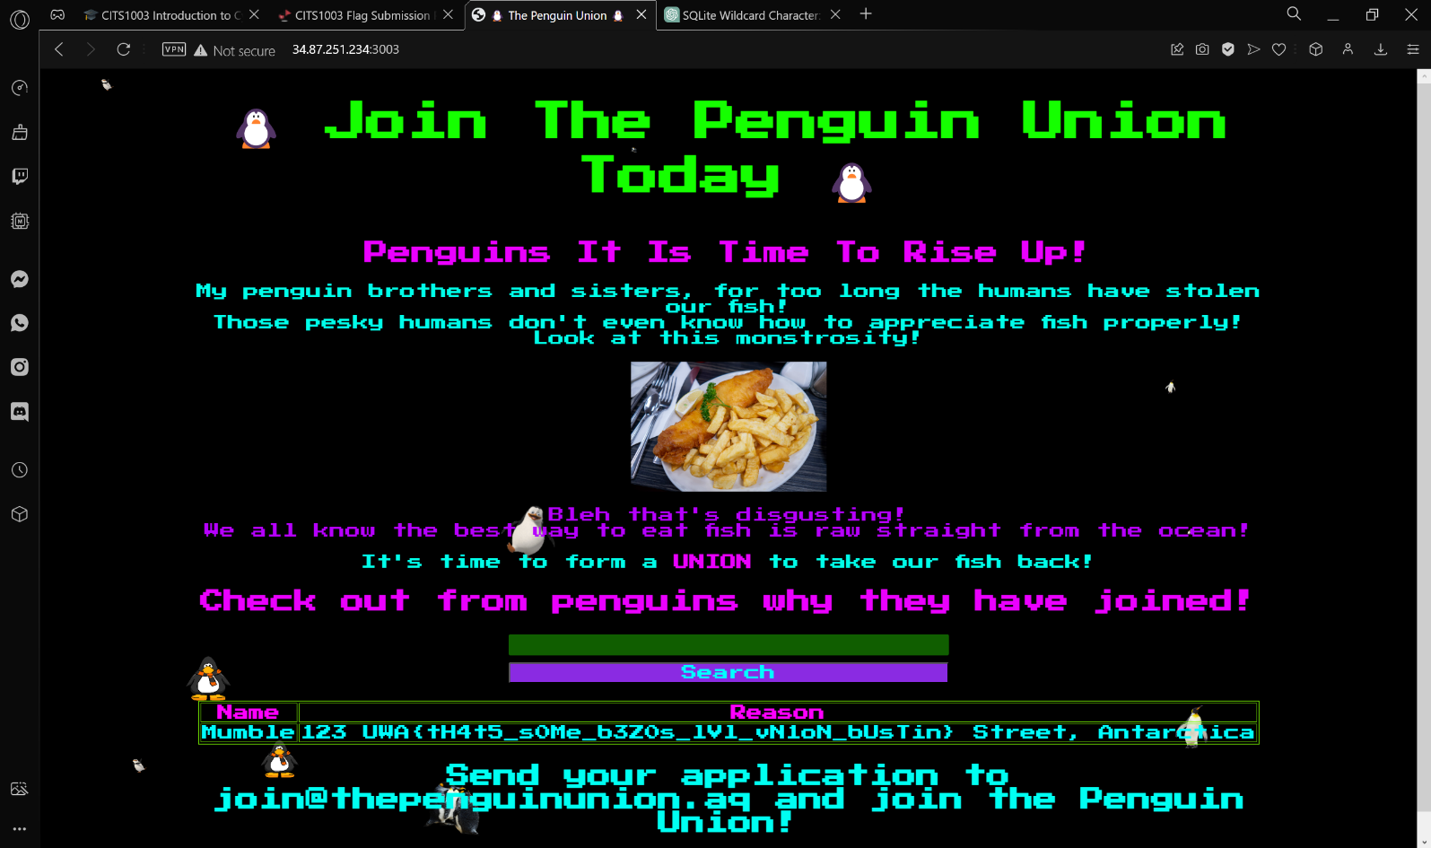

**Explanation:**

From the question, it is clear that we have to used the sql operation **UNION** to get the answer. The page always displays two columns only, so it is clear that we have to construct an injected query that returns two columns only. What the union operator does is, it performs union operation on the two tables (here the first two columns of the registrations table and **name,address** column of the same registrations column). **%** is a wildcard in sql query. When used with **like** operator, the query matches rows that contain anything within the wild card.

**--** is used to **comment** in the query language. This is **another important part** of this injected query as the query formulated comments out anything that appears after the initial fetching query. **This ensures that the original query does not interfere with the injected query**. We can alter the injection query that I have written to just **‘%p%’** which return **only addresses of Pingu and Skipper** as **Mumble** does not contain a ‘**p**’